**Industry:**Computer Vision

Video Conferencing

**Problem:**Supervised learning requires training data sets. The more training data, hopefully, the better performance of AI models. In computer vision space, drawing bounding boxes in training images might not be the best use of data scientists' time. Looking for an outsourced vendor to help labeling data can be challenging for a few reasons, for example how can we make sure that labelled images are good, qualified to put in model training pipeline?

**Competition:**There are existing firms that provide this labeling services. From what I've seen, there are local shops in China, India, and other countries that have competitive labor costs. Also there's Scale.AI, a unicorn that seems to be leading in this space.

**AI Opportunity**: Still there might be an opportunity to utilize AI itself to help streamline data labeling work to ensure quality of outcome. Semi automated system with AI recommendation engine could help increase fast turnaround time. And on top of that the outcome may not need to rely on human 100%, which are prone to create errors in labeled data sets.

Below is my response to homework in week 1 and 2. When I try to work on it, I try to make the problem more generalized to see a broader picture of the problem.

1) Design Sprint

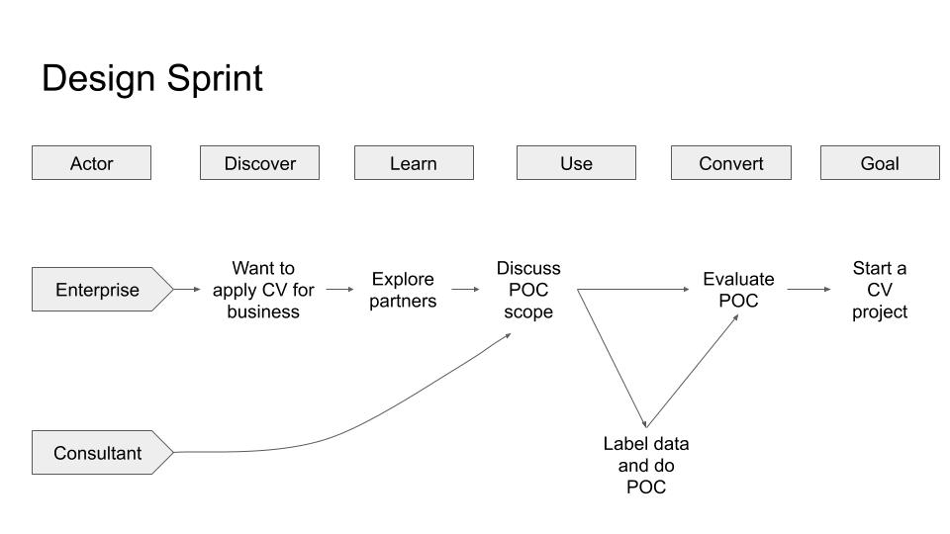

2) Buyer Utility Map

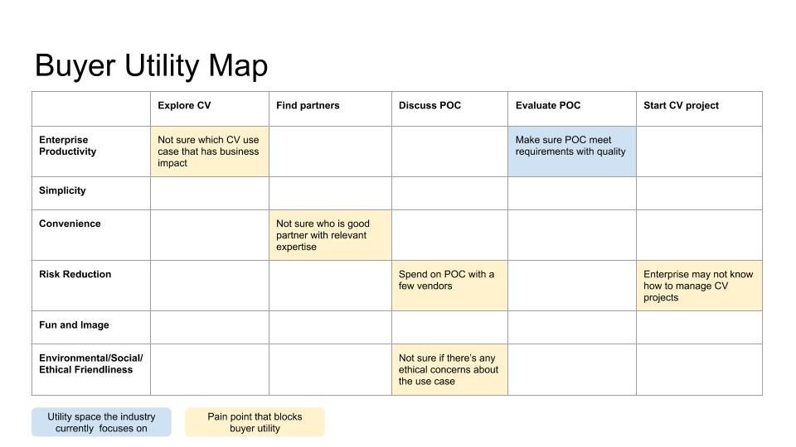

3) The four actions framework

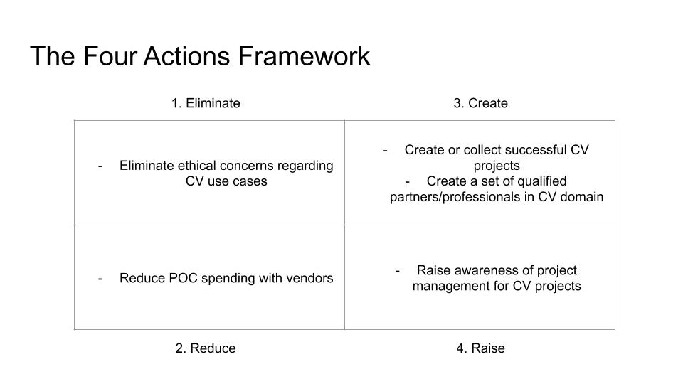

**Sprint Map:**

* **Long term Goal:** Automatically create meeting notes and highlights without having to manually capture them during a meeting
* **Sprint Questions:**
  1. Can we develop a ML model that can identify the context of the meeting and capture the correct boundaries of conversation to create valuable highlights?
  2. Can users shift their mindset to depend on automatically created highlights from their traditional ways of a note taker and typing meeting notes
  3. 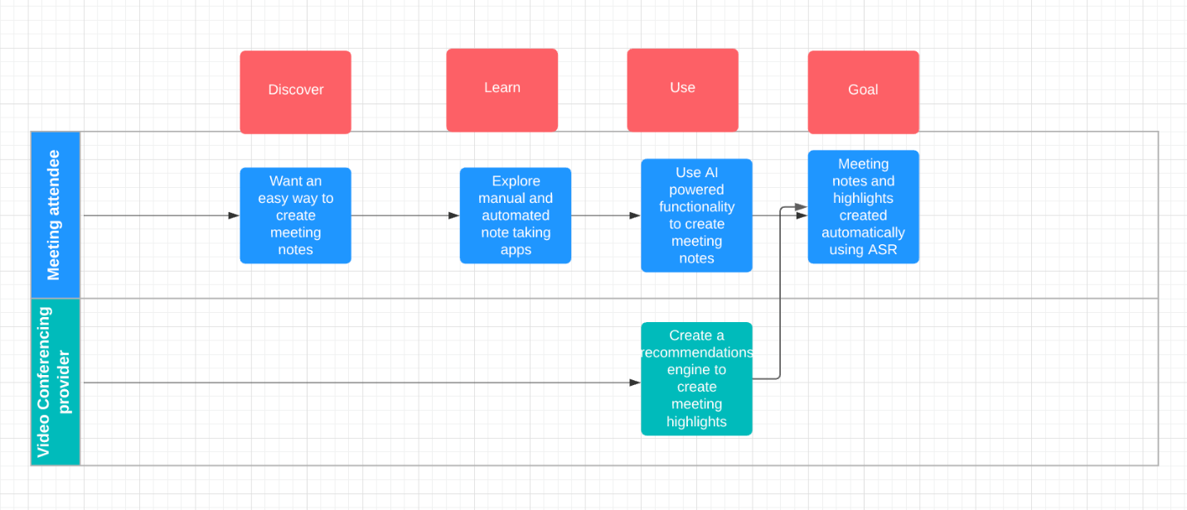
  4. The 4 actions framework:

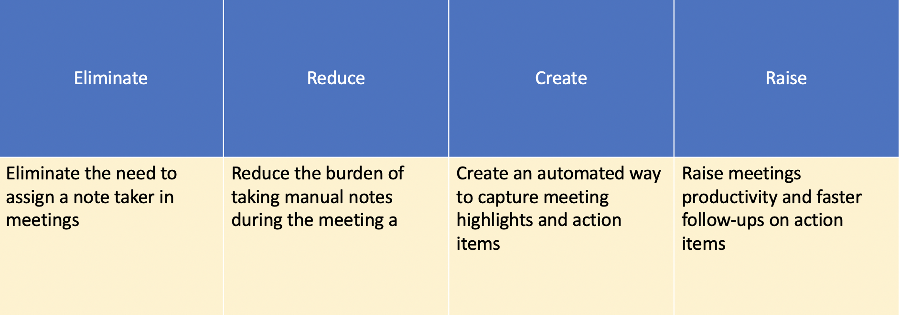

5. Buyer utility map:

* There are currently a lot of products on the market focused on improving productivity in work environments and in social environments, whether they are manual tools such as Notion for note taking or automated tools leveraging AI such as bluejeans and MS teams that offer live transcription and capturing video highlights from meeting.
* However there are still several pain points in what is currently offered in the industry since these solutions don't offer a replacement to the manual note-taking process but it rather complements it.
* Most of the products offered in the market are focused on offering a pleasing user experience that facilitate the task of note taking however it doesnt fully automate that job and takes it off the meetings attendees' plate.
* Leveraging AI to automatically detect meeting highlights has the potential to alleviate some of the pain points and capitalize on some the utilities currently offered by the industry

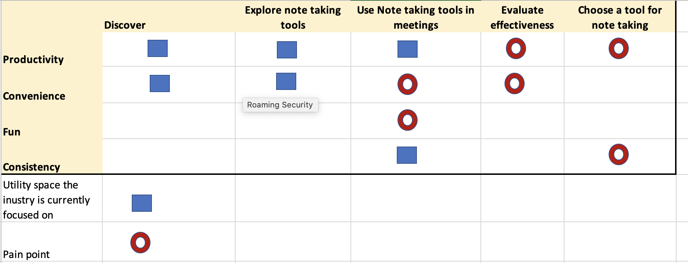

Homework #3:

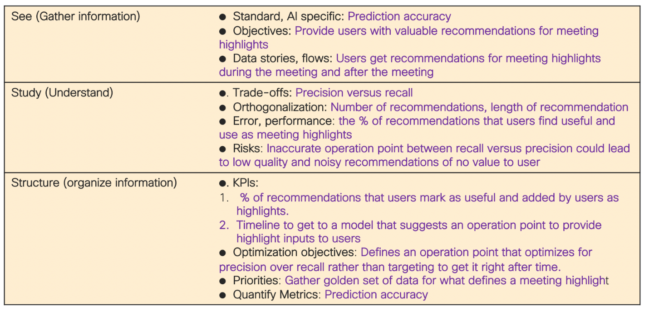

[Manage Discussion Entry](https://canvas.stanford.edu/courses/122184/discussion_topics/532794)

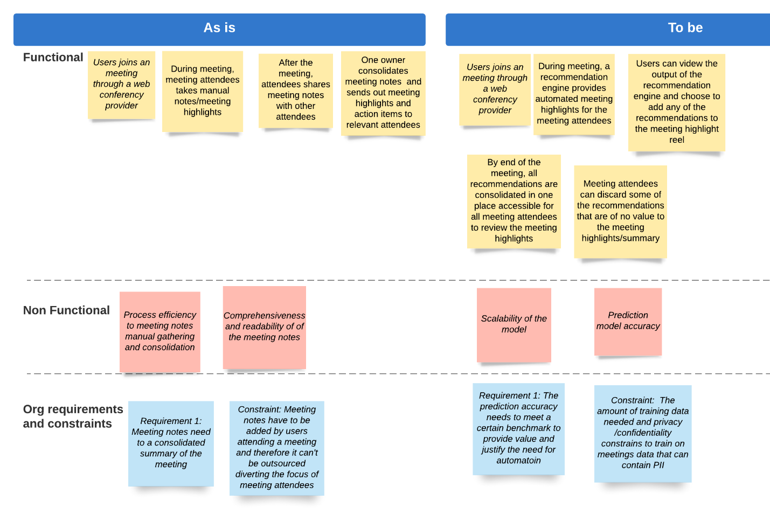

focusing on the data labeling process.

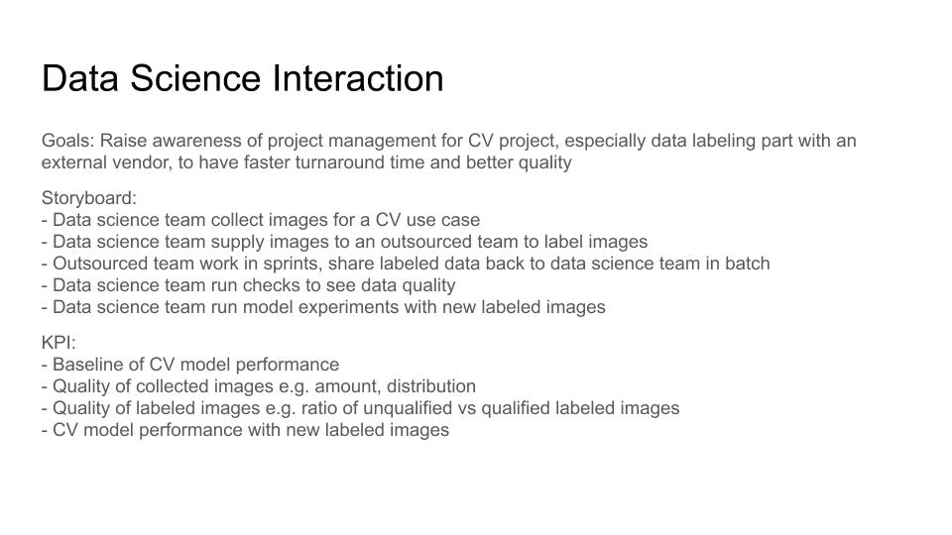

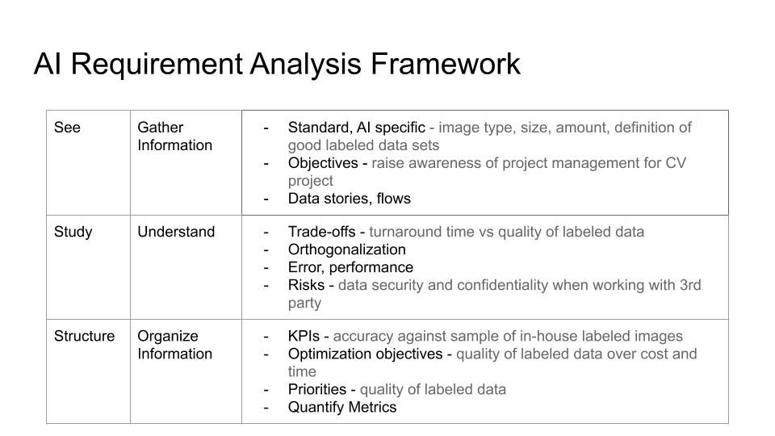

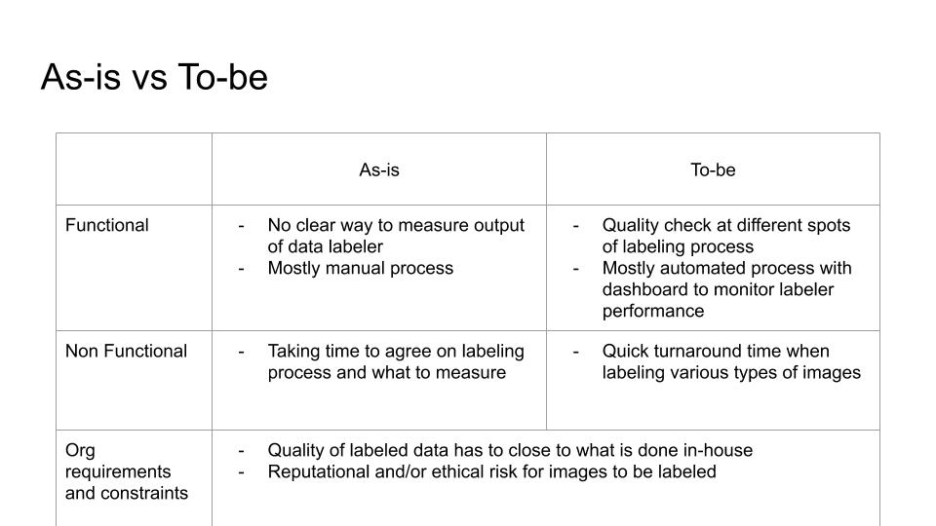

HW #4

* While looking at AIaaS solution for ASR engines, i couldn't find an API that provides the exact use case of a recommendation engine for meeting highlights.
* I looked at some of the AIaaS solutions in the market for ASR from a feature level comparison standpoint and I also utilized some of the out of the box API tests available for Amazon Transcribe and Google STT API
* Even though the feature I am trying to solve for can't be leveraged E2E using an AIaaS solution but it can be leveraged to build a model that would identify action items from transcribed text
* Below is the comparison between some of the main incumbents from a feature level and API test standpoint.
* I was unable to run a Word error rate measure for the different engines but it seemed like Amazon transcribe had better accuracy

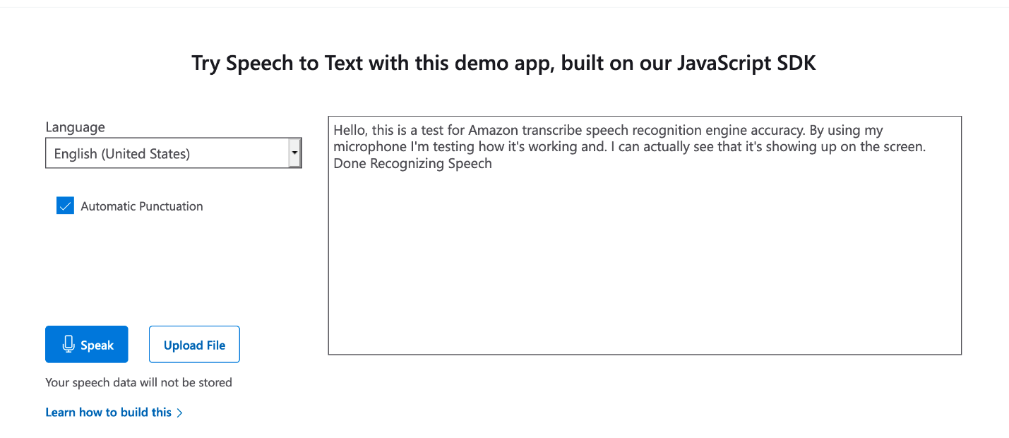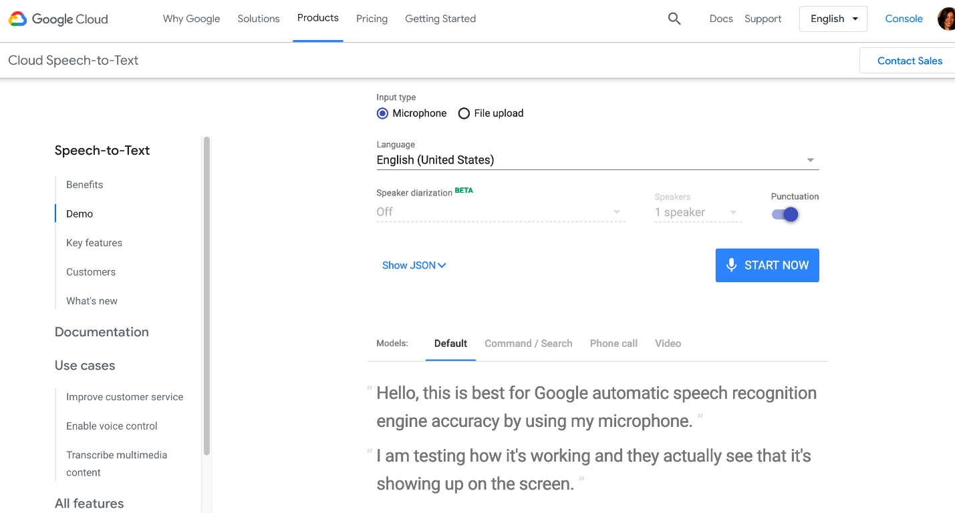

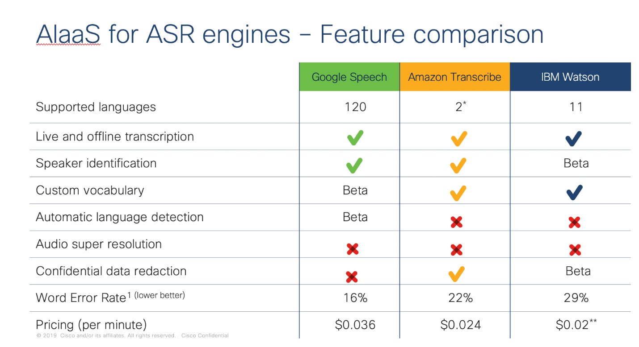

* Use a speech acts classifier that tries to capture the context and intention of the speaker in each sentence of a conversation.
* Classify each sentence as a
  + **Commitment [COM]**
    - “I will get started on the annotation guidelines right away.”
  + **Directive [DIR]**
    - “Can you sync up with the team in Oslo? ”
  + **Acknowledgement [ACK]**
    - “Yeah, makes sense”
  + **Elaboration [ELB]**
    - expands on a commitment or directive
  + **None [NA]**
* Accordingly, **Commitment** and **Directive** would indicate an action item from the meeting
* In order to train that model, we will need to collect a golden data set where meeting attendees would manually take meeting notes of their meeting and this data will be used to train the speech acts classifier
* The data set should include:
  + At least 50 real business meetings
  + 2 or more participants per meeting
  + Preferably more than one person would create meeting motes for the same meeting
* Upon recieving this data and training the classifier, the output of the classifier in determining meeting highlights will be sent to annotators to evaluate the accuracy of the model

Industry: Digital Advertising:

Problem statement:

Business Ad spending is getting more expensive. Because there are more businesses running Ads in a very competitive market place. They want to have a high-performance Ad that can convert their customers to complete the ad's goal without iterating multiple AB testing the Ad creatives.

Background:

Many businesses run digital Ads to attract and interact with their potential customers. The companies spend a ton of budget on the Ads, and they could only rely on their manual strategy on the targeting, placements, etc.

The advisers are running AB test campaigns to optimize the Ad's performance. They rely on the designers to create different assets from the copy, image, color, etc. It is a time-consuming and costly task and has to iterate many cycles before finding out the best outcome.

Objectives:  
Using computer vision and image recognition to analyze the assets and recommend the best ‘elements’ for the particular segments and Ad format.

Goal:  
Shorten the creative project lead-time and make it productive to deliver a creative set that converts the visitors to click.

User Persona:

Role: Paul  
He is a creative designer in the agency for 3 years.  
Who spends a lot of time on searching the best images stocks, copies that help to convert his client’s Ad campaign

Paul's challenges:  
Not every best practice works, and creating an incredible asset is a long thought process and cannot guarantee the outcome as expected.

 Role:  
Susan  
She is a marketer who is in charge of promoting the company’s product via the paid campaigns.  
She also works on multi-channels from email campaigns, search Ads, and display ads.

Susan's challenges:  
She has to run many AB tests to find out the best performing campaign, and it still involves a partial ‘guess’ work because the exact time of AB tests is different.  
She hopes to have a way to reduce the cost of AB tests and find the best campaign for her products.

 Fact: ( B2B)

* Ad spending in the Digital Advertising market is projected to reach US$129,436m in 2020.
* The market's largest segment is Search Advertising, with a projected market volume of US$55,216m in 2020.

<https://www.statista.com/outlook/216/109/digital-advertising/united-states>

One of the ways for the Companies to Advertise through Video Bloggers/YouTube Influencers channels is to arrange a Product Placement Marketing Campaign.

The process of management of that kind of campaign is manual because the Management Company needs to agree on the scenario, use of the Advertised Product, exposure, etc., and also to control the execution of agreements.

So, we can use AI to automatically control some or all of the Advertisement Agreement Provisions by applying automatic analysis to the videos created by each individual Video Blogger.

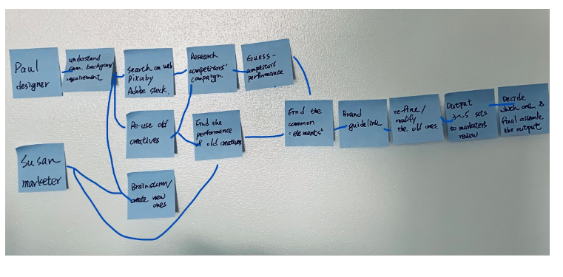

HW1

Sprint questions:

How might we increase the search volume and decrease the time spending? ( Discover)  
How might we analyze the competitor's campaign's performance based on the asset and channel? (Learn)  
How might we determine the working patterns and use them to extract/filter the exhausted research results? (Learn)

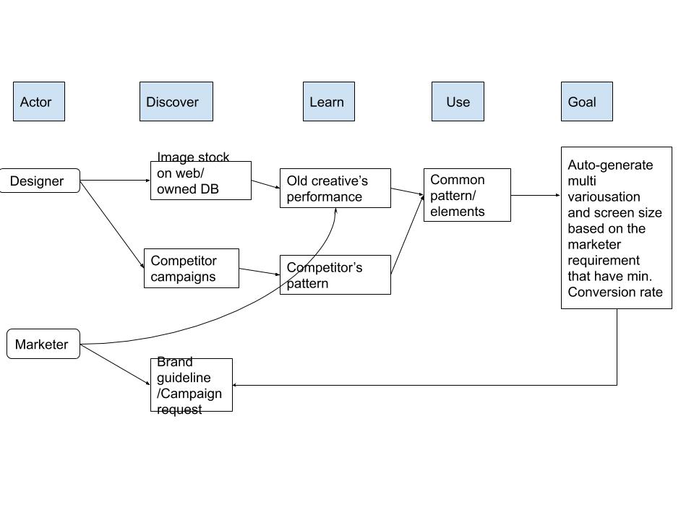

**3 Levels of product**

Core product:  AI engine

Actual product:  A web-based platform that can perform from search, extract, and re-assemble elements based on the given criterion to meet a certain level of CTR outcome.

Augmented product:  Rapid delivery of the marketing creatives.

HW2:

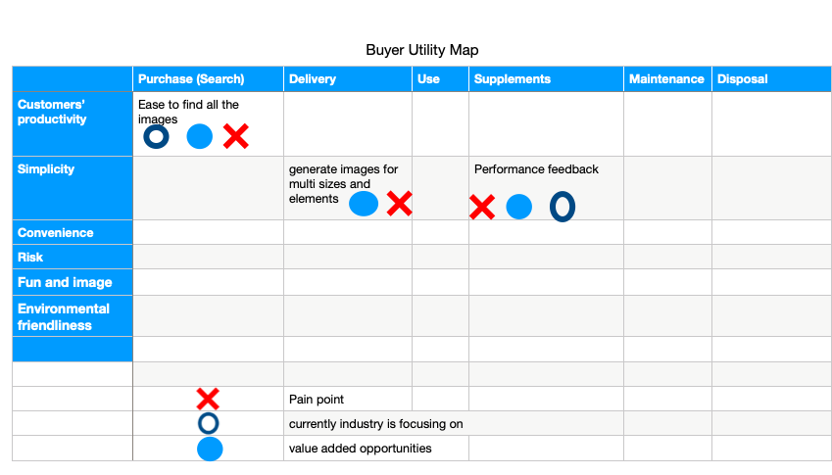

4 actions

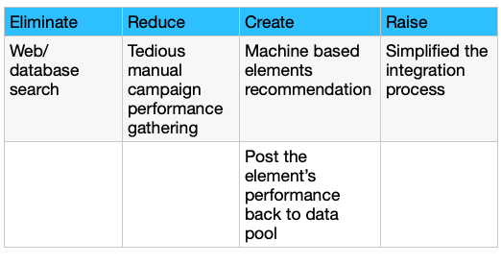

HW 3

See

- AI Specific: Understand computer vision and image recognition limitation, data requirement

- Objectives: Use the combined result to recommend the users the best assets.

Study:

-error/performance: Each campaign ran simultaneously, even with all control variables; the result is not 100% absolute. If you re-run, it will not have the same output.

Structure:

- KPIs  
   The -

- Optimization objectives  
   the conversation rate of the creative

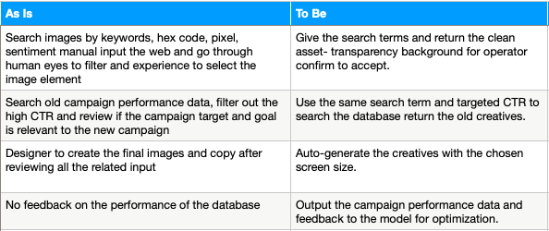

Edited by [Hsinti Wu](https://canvas.stanford.edu/courses/122184/users/121093) on Oct 26 at 3:39pm

How can we improve Joel's workflow by means of AI to help him to be more productive in Monitoring and Controlling of Advertiser's Product Placement and Advertiser Exposure for all the Vlog videos created by his Vloggers advertisement network? (Discover)

What else could help him to Grow Advertisement Network and be more productive at the same time? (Discover)

Core AI Product: AI Engine that will automatically analyze the vlog videos to search for specific Advertiser's Assets (logo, product, audio cues, etc) and analyze exposure to the potential clients of Advertiser.

Actual Product: Web-based Advertising Account Management System to Manage Vloggers Network and help Account Manager to Monitor and Contol Advertising Activities in Vloggers Network, related to Advertiser's Assets.

HW 2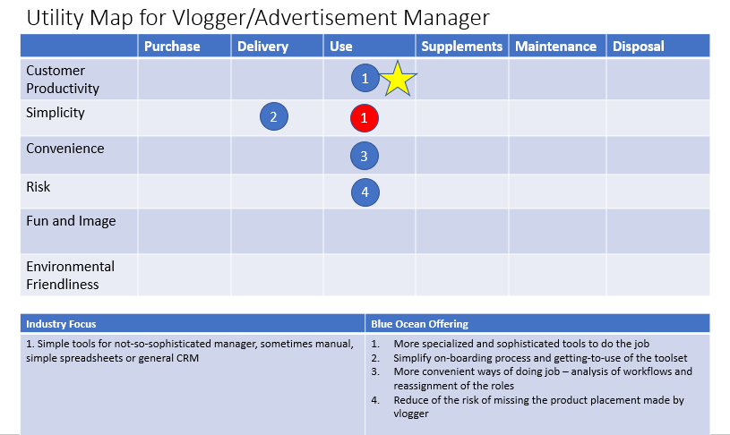

See:

Standard: What is the workflow for the Vblogger/Advertisement Manager today? Bottlenecks? Is views statics available and coherent for all vlogging platforms we are going to use?

AI-specific: What is the baseline for the current state of the art CV models to detect specific advertisement asset on the video? What are the limitations?

Study:

Understand the tradeoffs: what kind of ads assets will be available for reliable automatic detection by the models and if Advertisers agree to limit the assets types/kinds for more robust campaign management?

What will be the performance of the application of the AI models?

Can the new process introduce another bottleneck?

The cost of a new solution vs the cost of the old one?

Structure:

KPIs: No more than 5% of false not detected Ads Placements

Processing of vlog videos as fast as possible

Research Cycle

Set the Stage

PM Work:

NO MORE than 5% of not detected Ads Placements

Processing of vlog videos as soon as possible

Gather Solutions

DS Work

Research Proposals:

1. evaluate solutions to detect specific graphical assets on video

2. evaluate solutions to add new assets to track on video on the fly

Research solutions

1. Pretrained model + trained for specific Advertiser assets + trained again when new set of assets added

Evaluate

PM + DS work

1. The solution is viable

2. DS Models management software should be added to the tech stack for the project

3. Need to consider ways of augmenting Advertiser asset to create robust training datases

4. Need to consider the costs of maintenance of the software stack needed to implement that approach

SaaS Solutions

[https://cloud.google.com/video-intelligence/docs/logo-recognition (Links to an external site.)](https://cloud.google.com/video-intelligence/docs/logo-recognition)

[https://visua.com/logo-detection-api/ (Links to an external site.)](https://visua.com/logo-detection-api/)

Customizable solutions

[https://medium.com/@monkai/logo-detection-in-videos-cfcd0319cfe (Links to an external site.)](https://medium.com/@monkai/logo-detection-in-videos-cfcd0319cfe)

<https://github.com/aprettyloner/logo-recognition-from-video>

I finally decided to use IBM Watson for the solution.

AI PaaS

[https://www.ibm.com/watson-advertising/solutions/ibm-advertising-accelerator-with-watsonhttps://www.ibm.com/watson-advertising (Links to an external site.)](https://www.ibm.com/watson-advertising)

Reason:  This solution exactly provides the goal of this project, and we can not only reduce the numbers of creatives but also with a certain threshold for the ideal conversion rate.

It helps the team to getup running fast.

 The team can focus on delivering a viable feature/product to stakeholders. Then it can have funding to keep it going, fine tuning for better model.

* Advanced Watson AI rapidly learns the optimal mix of creative elements to help drive engagement

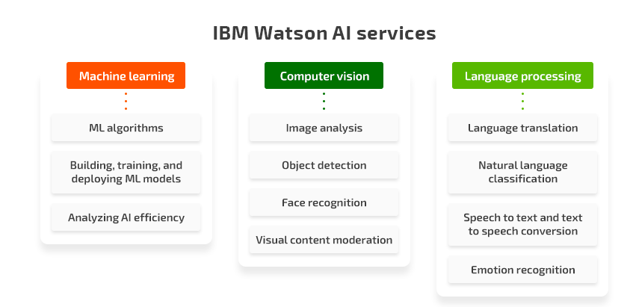

**Industry:** Manufacturing/ Process Industry

**Problem Description:**

A lot of manufacturing processes are monitored and controlled manually. This results in waste or lower quality product due to human judgment error or lapse. We need to automate the monitoring and control of these machines. So that we can capture near-real-time abnormal behavior and alert the control room operators about impending process failure, and optimize the machine set-points(controls) to increase productivity without any delays or waste.

**Background:**

In a coal wah plant, we want to optimize the machines in a way that the control room operators know what set-point (controllers) to change in what machines to what level so that it produces the maximum amount of clean coal with the required composition (ash/moisture percentages) without any delay of manual interventions.

The process we want to focus on is to wrap a thin wire on a heated rod. The operator has to track whether the rod temperature stays within a certain range and whether the wrapping wire doesn't rub against other moving parts in the equipment which will damage it. Currently, **operators have to manually check** the rod temperature and the wire position and make a decision whether to adjust the machine to bring them back in the spec. This **causes delays and/or wasted product**.

**Industry:**Mining

**Domain:**Coal Processing

**Sub-domain:**Coal Washplant

**AI Opportunity: Automation and Optimization opportunities**, to improve working processes, remove human error, high cost, and increase productivity.

**Background:** Throughput or input of raw coal is obtained by mining ore body, the raw coal is brought to Coal wash plant before it goes to the supply chain. From the raw coal, the plant has to remove a certain amount of ash and moisture so that we produce clean coal with the required ash- moisture for customers.

**Product Opportunity:**Keeping the same amount of throughput of raw coal we want to increase the amount of clean coal (yield). Yield is pure profit which is how efficient we are in the wash plant. We cannot increase throughput/input of raw coal as that will increase the cost and damage the environment so we have to have a solution that will remove *human error* to make the plant *highly efficient* by *optimization* of machines so that we *reduce mining cost* and *increase our productivity*.

**Why AI?**Everything is manual and depends upon the experience of CROs, which means a lot of human error and most importantly the lost opportunity to make the machines more efficient and optimized to increase productivity.

**Problem Description:**

***Ideal****:*In the Coal wash plant, the machines should be as optimized as possible by drawing insights from historical data of specific coal types to produce the desired amount of uplift and yield of clean coal.

***Reality***: Currently, all the machines are controlled by control room operators with their experiences only and without any knowledge of historical data and insights for specific coal types.

***Consequences****:*The incremental loss of efficiency and productivity is not letting the company achieve its yearly production goals and also loose profit margin due to the waste of clean coal.

***Proposal****:*To optimize the machines there needs to be the analysis of historical data along with more granular recent data of the machines’ performances by adding more sensors and developing a solution which could recommend the control room operators the set-points for individual machines which will maximize the efficiency and increase productivity without delay and waste. The solution has to give recommendations every 4 hours, as the lab samples are done every 4 hours, irrespective of product type

**Long Term Goals:**

* To automate all wash plant processes.
* To optimize the coal blend so that the wash plant could be more efficient.
* To recommend optimized set-points for machines to control room operators to maximize efficiency and higher productivity.

For the design sprint, choosing the goal: **To recommend optimized set-points for machines to Control Room Operators(CRO) to maximize efficiency and higher productivity.**

**Sprint Questions:**

* Will CROs accept the recommendations and comply with that?
* Do we have enough granular data (Example: Minute level ash, moisture, filter speed, Kero, MIBC, the specific gravity of Heavy Media, Spirals, 5th floor distributor, furnace temperature along with season , product type etc.) to make appropriate set-point recommendations?

Map:

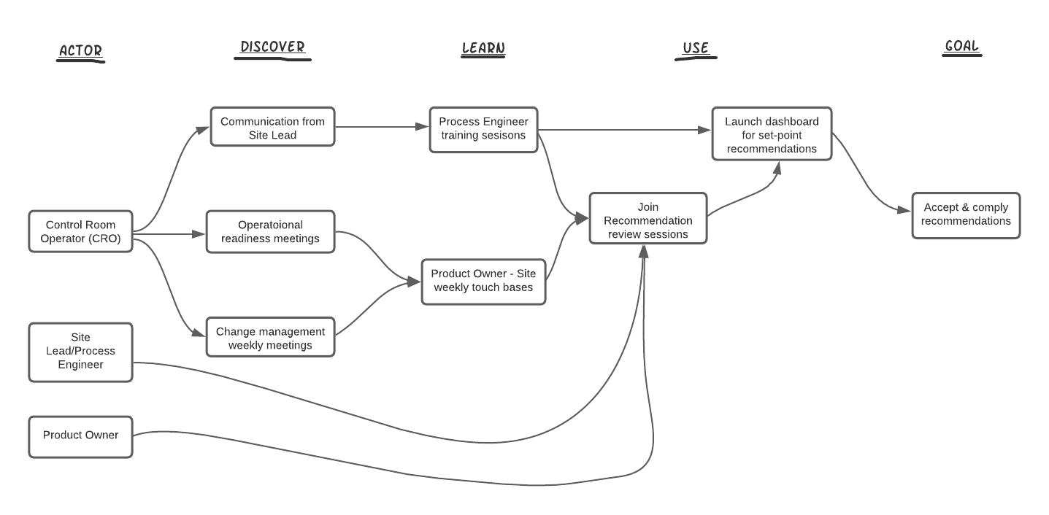

**HW 1:**

**AI Opportunity:** Automation of manual process to reduce waste and improve product quality

**Ideally,**the wire wrapping process runs within its operating parameters to produce a product that meets the quality specifications without any resulting waste.

**In Reality,**the wire position during wrapping and the substrate temperature needs to be maintained in a tight range to produce quality output. These moving parts or temperatures sometimes go out of range resulting in out-of-spec product or process interruption. The operator has to be vigilant to observe these parameters to manually adjust the process.

**As a Consequence,**the process yield and product quality is dependent on the operator reliability and judgment. This manual process results in out-of-spec product of the tune of $100K per year and process interruptions resulting in lost production.

The **Proposal** is to use a machine to monitor the wire position and substrate temperature in almost real time. This machine will analyze these parameters and predict a failure based on any abnormal behavior. The machine will alert the operator to take corrective action before the product goes out-of-spec.

Sprint Map:

**Long Term Goal:** Reliably predict process failure (by detecting abnormalities in position and temperature of the process equipment).

**Sprint Questions:**

* Can the model detect the abnormalities fast enough?
* Will the model be able to reliably predict the process failure?
* How will the AI Solution interact with the operators?



**Forestry:  Planner and sawmill optimization**

**Problem description:**currently  the lumber grading process is done manually (human graders) or traditional machine vision using high speed scanners.  This process is prone to human error or requires thousands of machine vision parameters to be tuned to detect defects for grading and sorting.

**Homework 2 :**

**Empathy Map:**

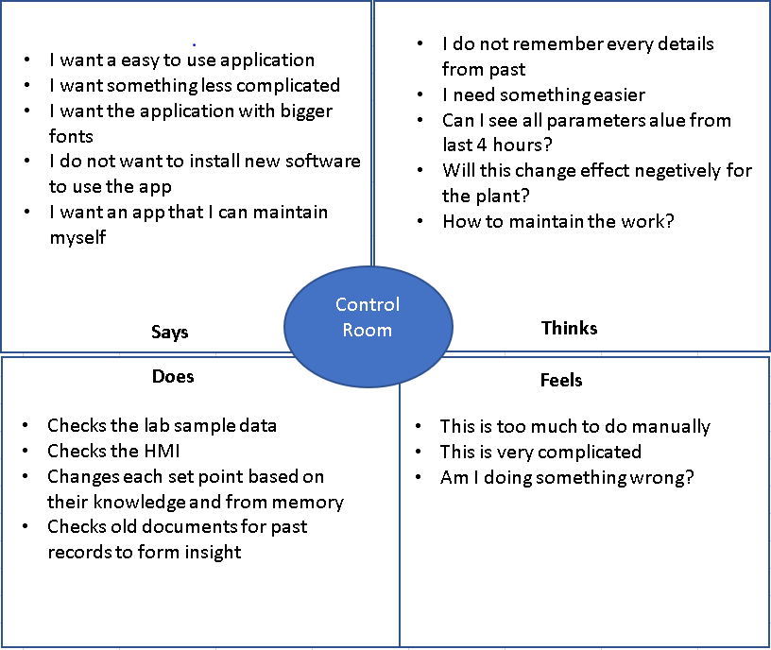

**Buyer Utility Map:**

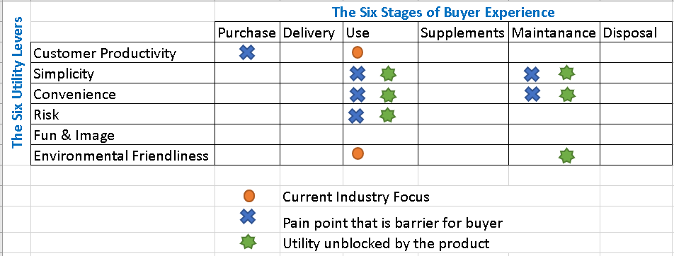

**Four actions framework:**

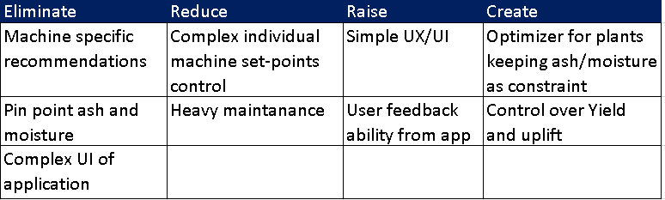

**Experience Using these frameworks:**

**I found these very useful, I have used the "Empathy Map" in my workplace and I have experienced amazing benefits of this map. Our UX design has evolved many folds. The "Buyer Utility" map is very thought-provoking and really helped me figure out the areas where we need to concentrate more and have higher opportunities.**

**Challenges:**

**The four action table, I found it gets difficult if we start with this without brainstorming on product areas of opportunity. The buyer utility helped me build the four actions.**

**Work-in-progress : Sketch of idea, validation from customer**

HW2:

Buyer Utility Map, 4-actions Framework and Empathy Maps are attached.

Buyer Utility Map Experience: I used the buyer utility map for the existing system. It became clear that the existing system focuses on simplicity of use and convenience of purchase. It, however, blocks user utility in productivity, risk, fun and image and environmental friendliness. The buyer is blocked from being productive and has to take significant risk in using and maintaining the system. The system is not hi-tech and fun and results in significant product waste which is difficult to dispose and is not environmentally friendly. These blockages of buyer utility provides glaring opportunities for the proposed solution to target. The areas which are ignored by the current system also provide opportunity for the proposed solution.

My Experience with 4 Actions Framework: I used the framework in two different ways. The first was to identify opportunities exist with respect to the problem statement to eliminate, reduce customer pain and create and raise customer value. The second was to identify what opportunities exist with the new solution to eliminate, reduce, raise and create factors as compared to existing process that could maximize customer value and minimize pain. The second way of mapping 4 Actions Framework clearly identified there is an opportunity to create customer value by providing near real time data about process performance and providing alerts to the stakeholders about predicted failures that the industry is not currently doing.

My experience with Empathy Map: Interesting was to identify the concerns/feelings and workflow of the buyer. Good pre-cursor to the user persona. Important tool to understand the buyer utility levers in the specific example.

Sketch is in progress.

HW3:

Objective: To develop an AI solution which predicts process failure for the wire wrapping process.

Key Results: No more than 1% false negatives on the ML prediction model (system didn’t predict the failure that happened). No more than 5% false positives (system predicted failure that wasn’t going to happen per as per the operator).

**SSS Structure:**

**See: Gather Information**

* Temperature measurement for every minute
* Wire position picture for every minute
* Objective is to predict the process failure based on the temperature measurement and wire position
* We know the process fails when the temperature is below a certain threshold and wire position is outside of a certain range.
* Models should be measuring these parameters and predict with the failure is going to happen based on the measurements.

**Study: Understand**

* Tradeoff of the frequency of data collection (real time video vs. once per minute) which will increase the amount of data computation and storage needs vs. early prediction.
* There is interaction between the two measurements- temperature and wire position
* Risks of false positives vs. false negatives. It feels false positive is going to be okay as the operator can manually check the system when he is alerted before correcting the process. False negative on the other hand could result in process failure as the system failed to predict a failure. The precision hence is more important than the recall, however we don’t want to cause too many false positives causing nuisance.
* The wire rotates at a high frequency, so there is a risk that the camera may not clearly capture the wire’s position in the image

**Structure: Organize Information**

* KPIs:
  + True positive rate (TP/TP+FN)
  + False positive rate (FP/FP+TN)
  + Operator satisfaction with the solution
* Optimization objectives: Optimize the false negative and false positive rates.
* Metrics: # of predicted process failures/month, # of actual process failures/month
* Priorities: Priority will be to reduce the number of actual process failures by predicting the failures before they happen.
* Constraints: Operator bias could be a challenge in measuring metrics. The technical constraints of capturing wire position every minute could be a challenge.

AS-IS/TO-BE

|  |  |  |
| --- | --- | --- |
| AS-IS |  | TO-BE |
| - Has to keep vigil on the process all the time | **Operator** | - Operator launches the AI Tool dashboard |
| - Manually make adjustments to the process to bring it back on track | - Operator gets an alert about failure prediction via pager/alarm/text |
| - Reset and retart the process if it fails | - Operator reviews the conditions and brings the process back on track |
|  |  |  |
| - No visibility on how the process is operating | **Plant Manager** | - Will have access to the dashboard |
| - Can't pinpoint root cause of each failure | - Can get alerts if desired |
|  | - Be able to analyze root causes of failures |
|  |  |  |
| - Manual logging of process data | **Data** | - Automated measurement and tracking of temperature and wire position |
|  | - Streamed data available on dashboard |
|  |  |  |
| - Once the process fails, restart takes time | **Equipment** | - Minimal restarts required as failures are predicted and prevented |
|  |  |  |
| # of process failures per month | **Metrics** | # of actual process failures/month |
| # of process failures that weren't caught by the operator | # of predicted process failures/month, |
| Equipment has acceptable yields | **Functional Requirements** | Model is accurate and provides limited false positives and negatives |
| Equipment is easy to set up | Model predicts early enough for the operator to correct the process before it fails |
|  |  |

**Story Board:**

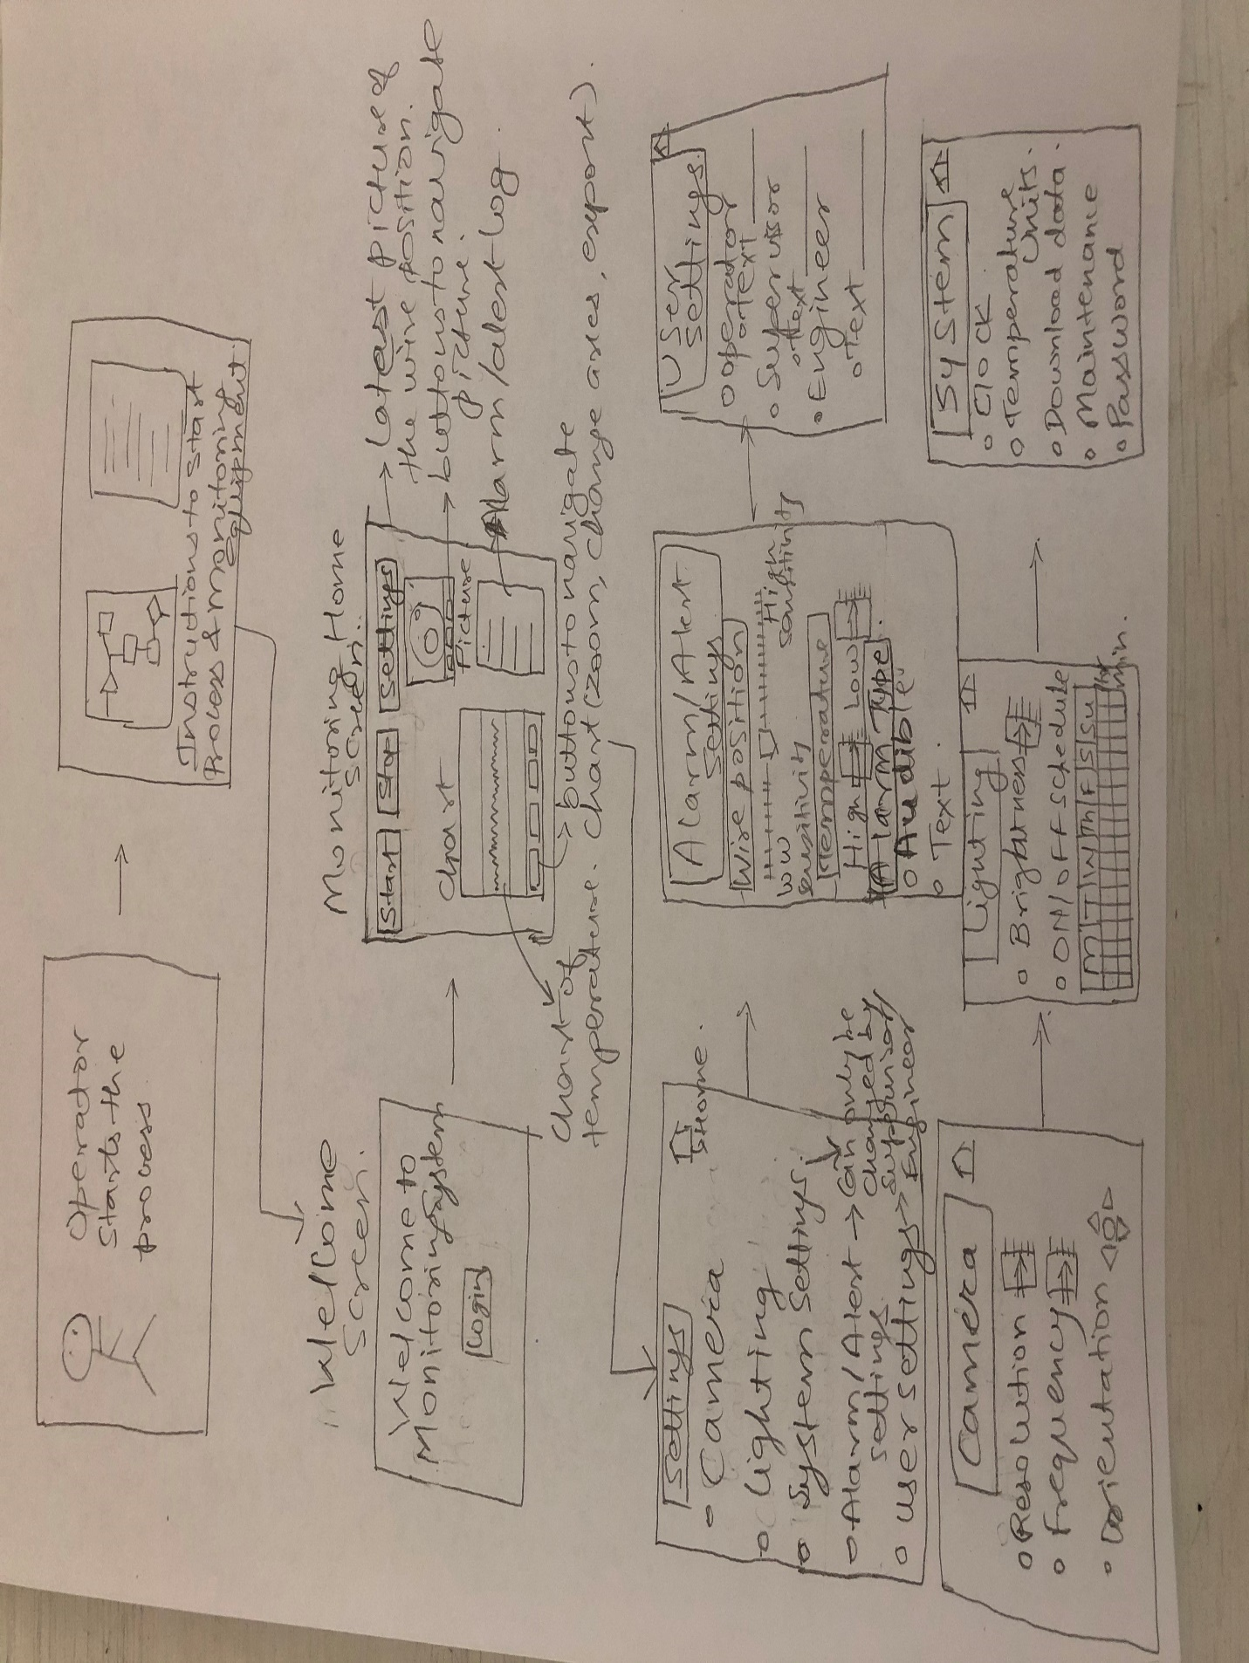

HW4:

1. If you have a friend or access to a data scientist, please run it by them and ask how would they go about it, what data they would need, how viable it and how much effort it will take. You can post this as a reply to the discussion.

If you know the upper and lower control limits of the temperature of the cable and the angle at which the wire gets wrapped on the cable, then you can just monitor them and have a system that will create an alarm as soon as your temperature or angle is outside the control limits. You don’t need a ML algorithm for that. However, if you want to predict the probability of having a process failure in the next minute or so based on the different process parameters, then you need a regression model.

First you would do the exploratory data analysis (EDA). EDA involves measuring and cleaning up the data, visualizing it, analyzing the data and finding correlating factors. Ask the subject matter expert (SME) what could be the reason for failure, what are the areas where the root cause of the problem might occur causing product failure. You determine with the SME on what areas/ parameters to measure, how to measure and how frequently to measure. You measure various process parameters, product features and plot them in every possible visualization. You identify occasions where the product was not good and try to find the correlating factors. It could be anything that you may not expect so try to plot as much data as possible. For example, weight of the cable, speed of the cable, fault in the cable heater, location of the rotating machine, vibration etc. Once you have plotted the data, you validate with the SMEs or operators that what you are seeing in the data matches what they are saying. Next step is the Feature Engineering, where you derive new features based on your data and enrich the information gathered with the help of SME.

1. Once you get your research and/or solution proposal, perform a prioritization based on viability, impact, and cost. In this exercise, you need to decide on the impact.

The research proposal is to build a regression model by visualizing data and determining the correlation factors when the product failure occurs. The prioritization will be based on the processes which cause the most frequent product failures. These processes will have the highest impact on the company bottom line.

1. If the data scientist asked for data, think of data acquisition and labeling solutions (page 14 on your handout). Remember the possibilities: public datasets, crowdsourcing, data marketplaces, data providers. Go out and find these companies, find the pricing on their website, or call them to get a quote and let them explain their approach. There is no better way to learn something in the real world than being the customer.

I called figure 8 and they make off the shelf datasets available for various machine learning projects. The mention sensor data on their website but no off-the-shelf sensor dataset was available. Lionbridge AI also provide many data services including data entry to data validation. Various data types mentioned on their website included text, audio and video. Phone calls to them were not returned. I also explored Oracle’s AI Apps. It appears that I can use these services for data enrichment but data collection will need to take place at the equipment in the factory using as many sensors as possible. Hence there will be a data acquisition costs involved.

1. Find alternative SaaS/AIaaS solutions (example: page 10 vs 11 vs 12 on your handout). You don't have to reinvent the wheel; use what is out there. Go to Amazon AWS, Google GCP, IBM Watson, Microsoft Azure to find solutions. Not a direct PdM task but it is good to get an understanding of the AI industry. We will talk more about this next week, but you can warm up this week.

I created an account on Google cloud platform. There are variety of GCP partners that offer AI/ML services. I found Pluto7 which offers a preventive maintenance ML App on GCP at the fees of $1200 per month. It collects data from all the sensors on the machine, uses Google’s IOT core and machine learning models to predict performance of the machine. We can use this service to predict the onset of conditions that can cause product failure in our example.

1. Post the data acquisition cost (if any) and SaaS/PaaS selection and cost to your team discussion board.

The data acquisition costs include the sensor costs and costs associated with storing, cleaning and enriching data. The costs associated are estimated to be $8000. The AIaaS model from Pluto7 are $1200 per month.

**Homework 3:**

***See:***

* Get the sensor data for every hour
* Lab sample data should be available hourly
* Yield and Uplift should increase
* Uplift should have a constraint and should not increase beyond 13 %
* Models should be predicting another constraint before optimization

***Study:***

* Accuracy trade-off with the sensitivity of the model as we want both
* The risk of pinpoint prediction could be not having granular sensor data
* Might need frequent retrain of the model and adding more sensors

***Structure:***

* KPIs: Uplift and Yield
* Metrics: Accuracy, R square, Precision, and recall
* Priorities: Ash and Moisture model sensitivity, Optimisation model to be used with ash and moisture model as a constraint.

As-Is  To-Do:

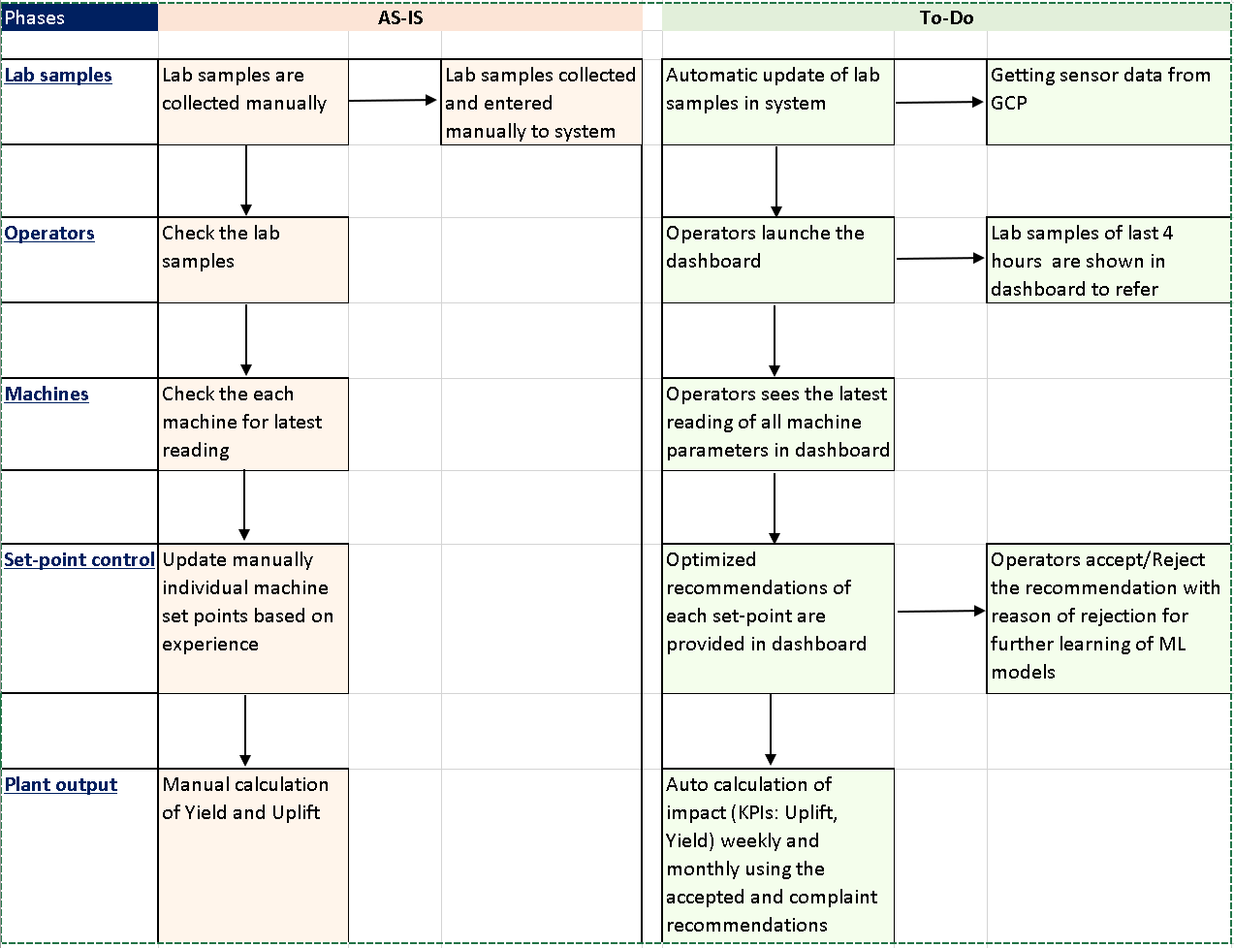

**Posted  Goals, Storyboard, KPIs, Requirements/Constraints, and solution proposal compiled into one message on the "Data Science Interaction".**

**Conversational Interactive voice response**

**Domain :** Insurance

**Subdomain :** Call Center for servicing Insurance Operations

**Desired state**: We want the caller to feel assured and confident that their call will always be handled in a way that exceeds their expectations. In an event, a caller dials 1-800# of the Insurance company. He/she should encounter a standard greeting, followed by  a speech recognition platform that will be a fully conversational environment for the caller. The combination of  conversational environment, and a reduction in prompt length should enhance the ability of the caller to navigate more efficiently to the desired department in a shorter amount of time.

**Problem statement**: When users dial the 1-800# of the insurance company, they interact with a  touch tone application, a highly structured process but with too many 'set' options. They are not being directed to the right departments, and are often being transferred to live agents. This has resulted in lower call containment, higher call handling time, increasing in costs and misdirected calls. This has increased dissatisfaction in many customers, and has lead to loss of business to competitors who have better Call Center Operations.

User Personas :

* All Policy holders
* Group Customer
* Broker
* New Customer

**Proposed solution :**

Enhance the current IVR with speech recognition system taking human factors into account as follows:

* How customers will think and perceive their tasks
* Speech should be the primary means of input for most initial prompt
* Getting to the point quickly.
* Keeping verbiage as brief as possible.
* Keep menus as heterogenous as possible.
* Ask for most accessible information.
* Do not ask but to simply give.
* Give callers time to respond.
* Design to ensure the caller is not at fault.

**high level User journey:**

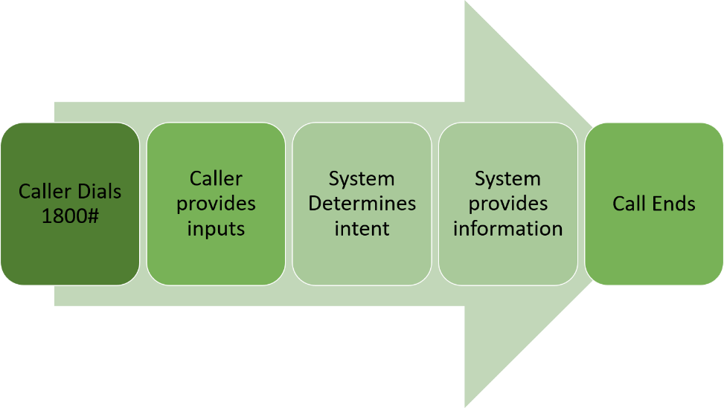

**AI opportunity:**

**What the application does**

The automated telephony-based service allows the Insurance provider to welcome callers, determine the call routing destination, and route appropriately. These services will be delivered with the general goal of allowing callers to accomplish their business in a satisfying and comfortable manner.

About 80% of the callers are customers who dial the number1-800#1. About 20% dial 1-800#2. Both these numbers reach the call routing application, but some of the call flow and prompting differs, depending on which number was dialed.

**Opportunities :**

**Optimization of underperforming automation**

* Too many repetitive messages and Business jargon
* Inconsistent use of terminology
* Inconsistent error handling
* Too many misdirected calls

**Expansion opportunities**

* Replace the existing IVR with an intent-based Conversational IVR (CIVR) across all insurance operations

**Optimization on costly manual process**

* Reducing mis-directed calls
* Reducing Directory calls (calls that default to the Directory skill - a call queue consultants, log into to receive a specific type of call they are qualified to handle

**Conclusion**

While touch tone application are based on highly structured hierarchies, speech recognition is more flexible and adaptable. Speech recognition applications can understand the words and phrases that callers speak into the telephone and can trigger appropriate responses.

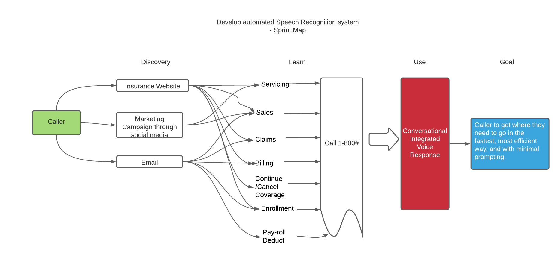I am attaching herewith the sprint map for  the Conversational Interactive voice response.

I have laid out a four actions framework  on what can i really look at other products, looking at other competitive environment. The framework focuses on factors which are actually taken for granted in the industry, this gives the value drivers for the solution.

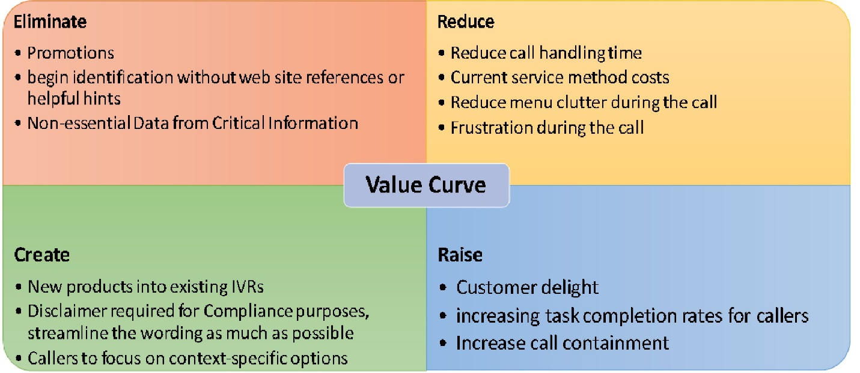

KPIs :

* Percentage of total IVR call volume that hangs up in the application (i.e. abandonment or navigational hang-up) is not higher than historical trend from legacy Call Routing IVR
* Improve performance across key metrics  
  including misroutes, containment,  
  and automation success rates.
* cost per transaction  
  and average handle time

|  |  |  |  |  |
| --- | --- | --- | --- | --- |
| RISKS | | | | |
| Cause | Effect | Impact (High, Medium, Low) | Probablity | MITIGATION |
| (As a result of…) | (risk event – may occur) | (HIGH, MEDIUM, LOW) |
| Inaccurate/missing business requirements | Business benefits will not be realized. Rework may occur. | High | Low | Continuous engagement with IT and Business partners to validate requirements accuracy and feasibility. |
| Limited availability of IT and Enabling Services resources for deployment | Risk to deployment date | High | Low | Engage required partners early |
| New telephony circuit | Delays to Telephony circuit deployment will delay the production deployment of the Interactions Call Routing CIVR. | High | Low | Continuous engagement with Infrastructure team to determine roll out of new telephony circuit. |
|  |  |  |  |  |
| Orthogonalization | Call Routing CIVR Logging |  |  |  |
|  | Call Routing CIVR will log all data elements required by Call Routing CIVR reporting. |  |  |  |
| Call Routing  CIVR Reports Call Routing CIVR reports will support reporting on at least the following metrics: 1. For each product to which the IVR can route calls, count of how often that product was identified |  |  |  |
| Count of calls for which no product was identified. i.e. default routed |  |  |  |
| Count of calls transferred to each route |  |  |  |
| Work Condition Report is a monthly output of Call Center Reports and is specific to internal reporting |  |  |  |

|  |  |  |
| --- | --- | --- |
| As - IS | | |
| 1 | Caller Personas | All Policy holders, Group Customer, Broker, New Customer |  |
|  |  | There are numerous toll free numbers associated to Call Routing IVR allowing the caller to choose a product and route to the appropriate destination. | |
|  |  | The application is in English only and will use both DTMF and speech input. |  |
|  |  | Automated number Identification identifies the phone number that the caller called the IVR application from | |
| 2 | Functional | 1-800-#1 - Menu options | After the call is answered, a greeting is played followed by the main menu |
|  |  |  | Product menu selections can be made either via touch-tone or voice input |
|  |  |  | Caller barge-in is supported |
|  |  |  | Caller selects a product and is then routed to the appropriate product IVR |
|  |  | 1-800-#2 - Menu Options | After the call is answered, a greeting is played followed by several prompts |
|  |  |  | Prompt: First, are you calling about a product you already have with us? |
|  |  |  | If Yes: And is this a benefit or policy offered through an employer or group? |
|  |  |  | If Yes or No: Next, tell me about the product you are calling about at anytime |
|  |  |  | If No: And do you have sales questions for a policy or account purchased through an employer or group? |
|  |  |  | Yes: If you are a broker or employer calling to obtain coverage for a group, say employer otherwise tell me about the product you are calling about… |
|  |  |  | No: Please select the product you have sales questions about at anytime |
|  |  |  | Caller barge-in is supported |
|  |  | Product | Call Reason |
|  |  | Personal Insurance | Service |
|  |  | Personal Insurance | Sales |
|  |  | Group Insurance | Service |
|  |  | Group Insurance | Sales |
|  |  | Retail insurance | Service |
|  |  | Retail insurance | Sales |
|  |  | Property Insurance | Sales |
|  |  | Property Insurance | Service |
|  |  | Casualty Insrance | Sales |
|  |  | Casualty Insrance | Service |
|  |  | Legal Insurance | Sales |
|  |  | Legal Insurance | Service |
|  |  | Personal Insurance | Claims/Other Inquiries |
|  |  | Group Insurance | Claims/Other Inquiries |
|  |  | Retail insurance | Claims/Other Inquiries |
|  |  | Property Insurance | Claims/Other Inquiries |
|  |  | Casualty Insrance | Claims/Other Inquiries |
|  |  | Personal Insurance | Pay-roll Deduct |
|  |  | Personal Insurance | Billing |
|  |  | Group Insurance | Billing |
|  |  | Retail insurance | Billing |
|  |  | Property Insurance | Billing |
|  |  | Casualty Insrance | Billing |
|  |  | Personal Insurance | Continue/Cancel Coverage |
|  |  | Property Insurance | Continue/Cancel Coverage |
|  |  | Casualty Insrance | Continue/Cancel Coverage |
|  |  | Legal Insurance | Continue/Cancel Coverage |
|  |  | Personal Insurance | Enrollment |
|  |  | Property Insurance | Enrollment |
|  |  | Casualty Insurance | Enrollment |
|  |  | Legal Insurance | Enrollment |
|  |  | Group Insurance | Enrollment |
|  |  |  |  |
|  |  |  |  |
|  | To Be |  |  |
|  |  |  |  |
|  | Req | Description | Comments |
|  | 1.1 | Regardless of the user experience the automated number identification match is always performed. |  |
|  | 1.2 | If automated number identification match is successful and caller selects product from automated number identification match, then route to appropriate destination. |
|  | 1.3 | If automated number identification match is successful and caller does not select product from automated number identification match | Refer to Current State section under Product Breakdown in this document to see list of Products/ Call Reason |
|  |  | or |
|  | 1.4 | automated number identification match was unsuccessful with no match found …then prompt caller for desired product and route to appropriate destination. |
|  |  |  |
|  | 1.5 | Additional disambiguation questions may be required for caller to be routed. Whether it’s 1-800#1 or 1-800#2 the caller needs to select a product. 1)     1-800#1 – Further prompting is needed to determine if caller wants Retail or Group. |
|  | 1.6 | Continue to support selected barge-in where there are long lists of available products with focus to eliminate long lists. |  |

**Industry: FOOD RETAIL:**

**Problem Description:**

Grocery stores often discount items that are short-dated or out of season in order to sell through excess inventory. Any dollars are better than no dollars if it has to be thrown away. The problem is shoppers have a hard time finding these items especially less popular items.

**How might we make shopping in store for sale items easier for people so they save money on groceries?**

Busy shoppers should be able to find what they need when they enter the store. Store flyers are often sent out week ahead of sales and shoppers then have to find the items in the store to save money on groceries. This can turn into a scavenger hunt.

**Problem:**

Busy shoppers need an easy way to find on sale merchandise faster.

**Value for consumer**

On average we spend about 60 hours grocery shopping per year. Imagine what you could do with even half of those hours back in your life

**AI opportunity**

To solve the pain points of users so that sale items are easy to find throughout the store.

**User Persona:**

Shelly, 35, mom to 3

Grocery shops all week long at different stores

Stay at home mom to small children

She has to buy special items for each child

Some items are only available at certain stores

She spends on average $200 a week on groceries

Goal:

Save money

Find items quickly

Personality:

Trendsetter

Tries new things

Extrovert

Tim, 75 Grandfather

Grocery shops every 3 days

Searches for a bargain

Fixed income

Trouble seeing

Uses a cane

Goal:

Buy items on sale

Save money

Personality:

Loves a deal

Social

Homework Week 1:

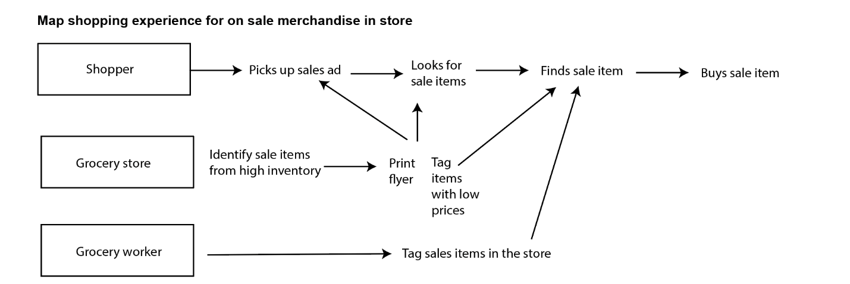

Homework Week 2:

**Six Utility Levers Mapping**

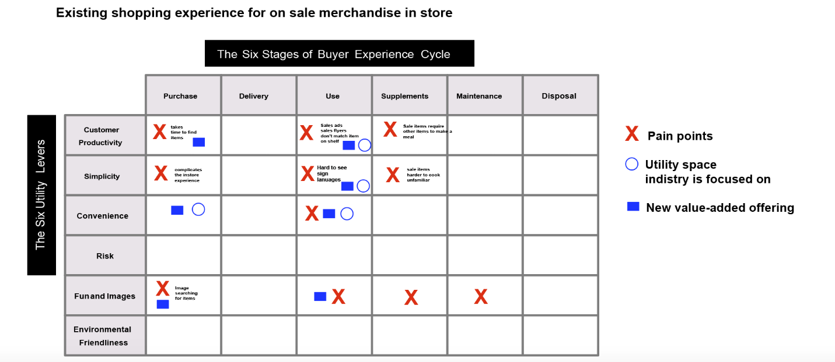

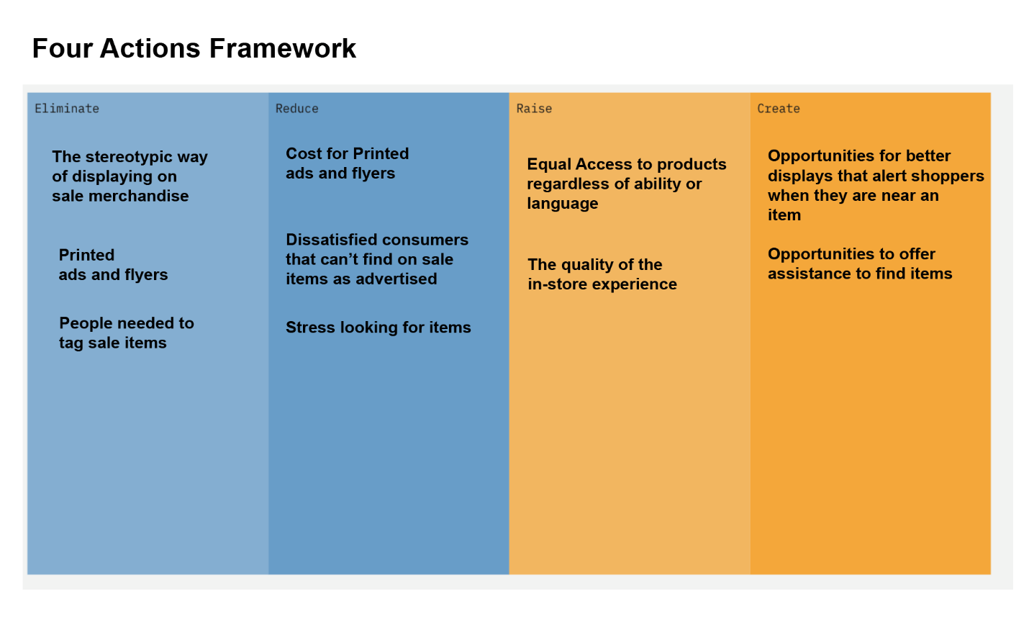

Philip Kotler - 3 Levels of product

1. Core product

Physically interact with goods

2. Actual product

Low prices for what I want to buy

3. Augmented product

* Find my items on sale when an item goes on sale
* Locate things in the store easily
* Find items on my list that are on sale
* Notify me
* Translate sales in my language
* Help me see items that are low on the shelf or hard to read
* Speed up the transaction of sale items that are out of stock so I can buy it when it is in stock
* Notify me of inventory at a store

 I chose to move forward with prototype is **better displays**. After showing my prototype to my personas, each participate in my user interview said this was a viable and they would use it, if this technology were available.

Prototype:

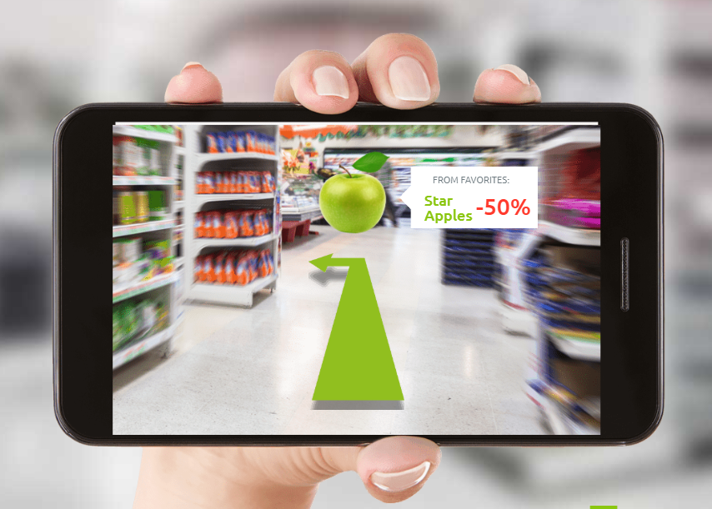

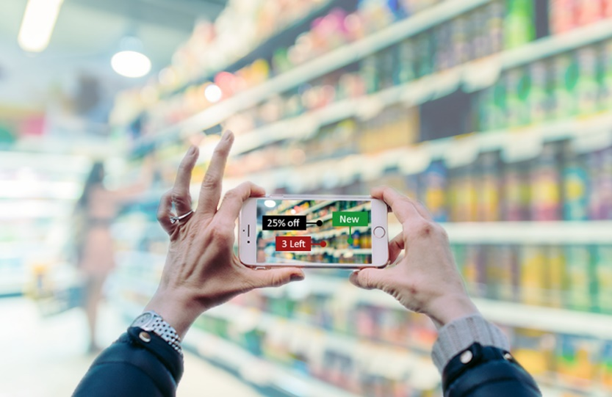

A question on your prototype - is it, as your picture shows, App based augmented reality solution? Would you for see a challenge in getting someone who might not be tech savvy like say Tim, the 75 year old grandfather, to use it regularly?  And, would there be a context switching challenge? i..e I am pushing my cart through the aisle, I have to stop, pull out my phone, aim it at the aisle, see the deals, put my phone away and then remember where they are?

V1 would require an app of some type or a device BUT I do think the trained AI model would work best with Apple or Alexa glasses or an integration into a shopping app like instacart.

It works for instacart because users have the app open and are already engaged in the app. The prototype was presented to users to get an idea of the experience. I still don't know how this would be possible but I did want to show the ideal experience so I could get a reaction.

Smart glasses like Apple or Amazon smart glasses will come soon and I do think these overlays will be a way of life. Do I think a 75 will be an early adopter - (Probably not) Good observation and thanks for your feedback. I think ultimately this could also work with any device - maybe its a device already in the store the shopper picks up and uses but I agree holding a phone isn't the ideal experience.

Thanks for the input Tommi, instead of a phone based solution would a system of lights connected to the shelves be an ergonomically easier indicator? So you could just look down the aisle and the lights will indicate where the deals are? This could be combined with a smart cart, so as you pass by the lights on the shelves where the deals are come on, and the screen on the cart shows the deals.

I agree! I think the how is up to the engineering team to decide. If it meets the same end goal it works.  This falls in line with the outcome of "**better displays".**

I agree a "smart shelf" is much better, great feedback!

Doesn't require a device, easy to adopt right away, save money on printed tags. Basically it works for every persona. It meets the design criteria.

Looks like Kroger has something similar:

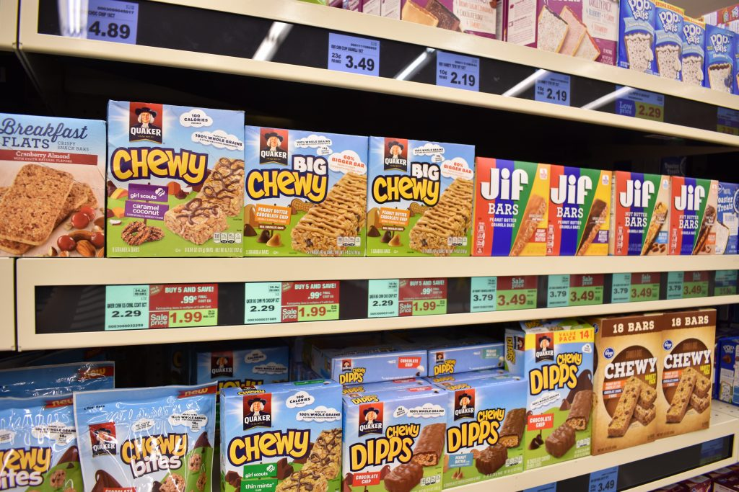

[https://news.microsoft.com/transform/kroger-smart-shelves-ditch-paper-drop-lights-delight-shoppers/ (Links to an external site.)](https://news.microsoft.com/transform/kroger-smart-shelves-ditch-paper-drop-lights-delight-shoppers/)

## [Subuddh Parekh](https://canvas.stanford.edu/courses/122184/users/266519)

Like you suggested, I think taking this concept a step further is adding a sensor, connecting another layer of personalization so that I'm alerted to what I usually buy or an item on my list.

Problem: Waiting in line is a major negative user experience, wherever the line is. Two areas that stand out: a) Waiting in line for checkin/security at airports b) Waiting in line for shopping at any store.

* Here are the full details of the problem and solutioning for week1 and week2. Since Amazon already provides this service the solution is already out there in some form, the question is can machine learning make it better/more ubiquitous.

[https://docs.google.com/document/d/1O_nRE19GJHJ0649CRks-F-hZn_tF5yOhqIM20byF_ow/edit?usp=sharing (Links to an external site.)](https://docs.google.com/document/d/1O_nRE19GJHJ0649CRks-F-hZn_tF5yOhqIM20byF_ow/edit?usp=sharing)

Synopsis

Problem Statement: Customers need to wait in line at checkout while shopping, which is very annoying, discourages some from actually shopping and in times of pandemic increases risk of infection.

Value for customer: Everyone loves to actually buy things at stores, but hates the checkout process. Anything that eliminates will be well received.

AI opportunity: For identifying accurately items in the cart.

Note: Amazon has already released such an experience at one of their stores in Seattle. So this is a known solution that way.  Can AI improve it/make it more ubiquitous?

Further details in the doc linked above.

[Tommi Tyler](https://canvas.stanford.edu/courses/122184/users/283784)

## [Tommi Tyler](https://canvas.stanford.edu/courses/122184/users/283784)

Oct 19, 2020Oct 19 at 10:23am

[Manage Discussion Entry](https://canvas.stanford.edu/courses/122184/discussion_topics/534310)

Hi I have done a lot of analysis on shopping cart. This is a good problem to investigate especially since the shopping cart hasn't been modernized in decades.

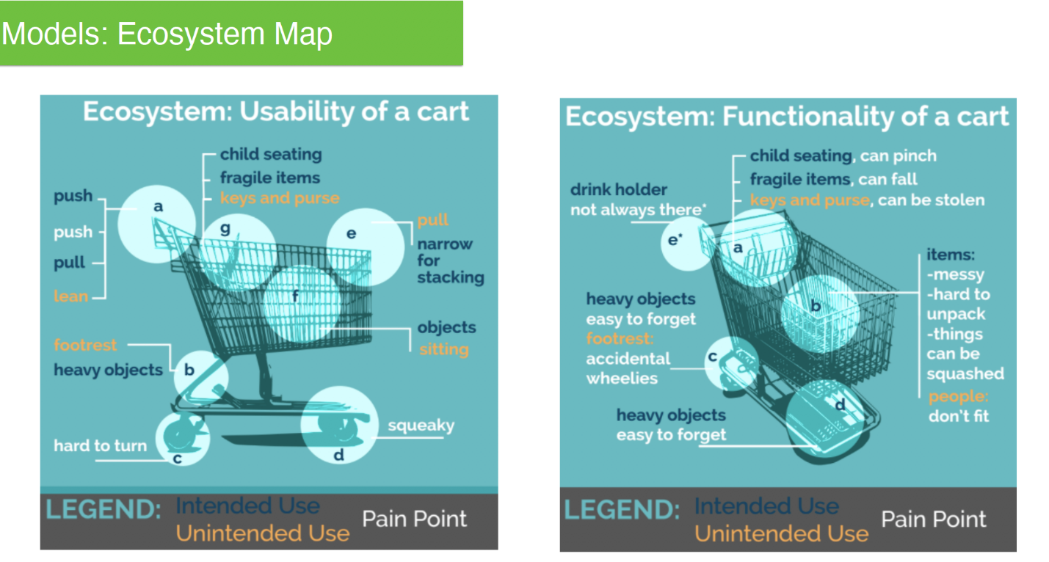

I think the core product is shopping in person

You are adding value at every stage. I still see this is as an alternative to "self-checkout" The problem with self check-out is it hardly ever really works and if you notice requires a real human to monitor the check-out of the store.

The other issue, what if I don't use a shopping cart? Maybe I have only a few items or what if I shop for someone else?

my kids ride inside the cart. How would that effect check-out?

This is an alternative to the Amazon smart cart:

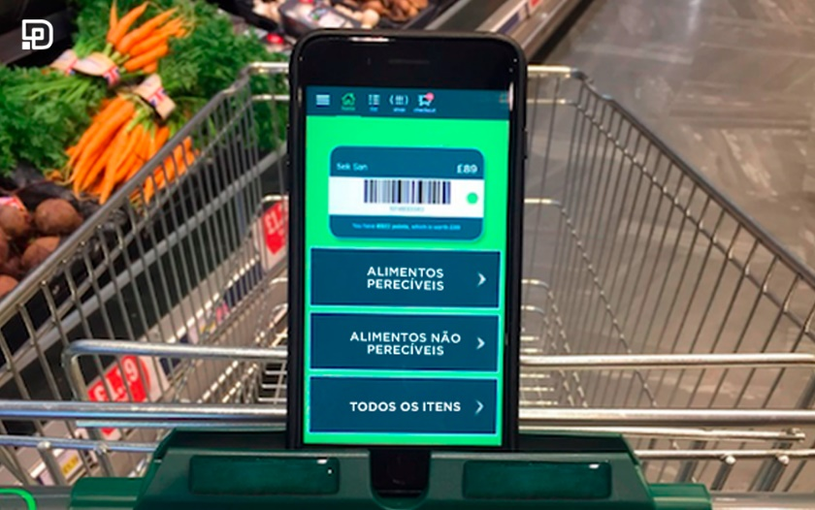

And here is the user testing -

User - mid thirties occasional shopper.

Unlikely to use product. Likes having items bagged for them. Doesn't mind lines, goes shopping when there are less lines.

User - late thirties frequent shopper who uses self-checkout.

Will use product only if savings are passed on to them.  Worried about breaks in the process of using the product that will cause more delay than lines.

User - late sixties frequent shopper who uses self-checkout.

Will enthusiastically use product unless it fails and needs some manual intervention.

In short, bagging is really important. And this is an all or nothing experience. Either it works completely and delights the users, or it causes intense frustration if even a tiny part breaks.

**SEE:**

Right recommendations at the right time that improve instore engagement and delight the shopper

* Understand shopper individual preference
* Understand Shopper intent
* Match sales to shopper behavior

**STUDY:**

Price can be wrong

Biased algorithm

What if some brands are recommended more than others

What if an item is recommended that should be secret, flowers wine or some item that is in a family?

Implications for the existing ecosystem

How will brands compete in this new environment?

**STRUCTURE:**

KPI: Items purchased, engagement of feature, number of users

Quantifying metrics: More revenue

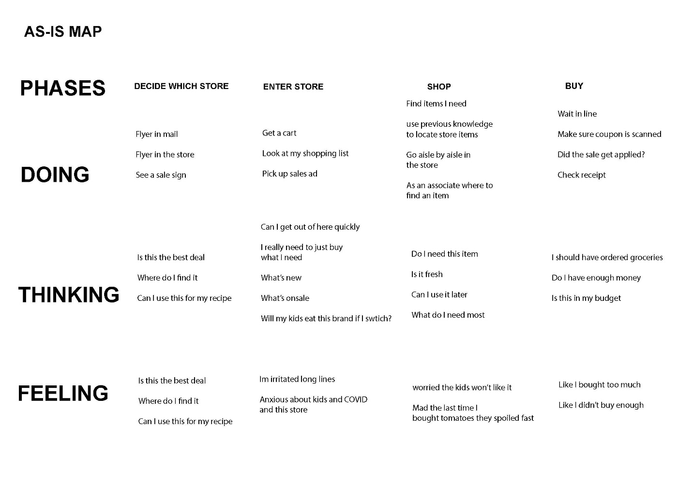

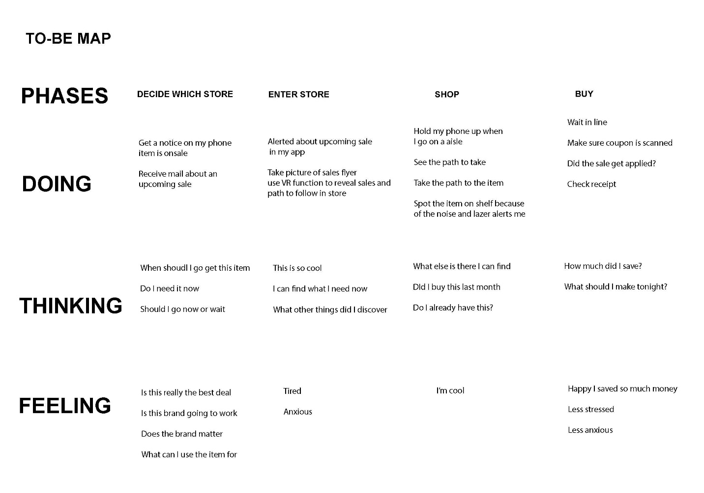

When performing as-is/to-be analysis it is important to call out functional, non-functional, and business requirements along with the quantifiable KPIs. The shopping cart recommendations, for example, a device attached to the cart that shows recommendations in a certain way to the shopper could be a functional requirement. The accuracy of the recommendation and the size of the screen could be non-functional requirements. And the fact that your company wants to use android devices could be some business requirements.

**SEE:**

Right recommendations at the right time that improve instore engagement and delight the shopper

* Understand shopper individual preference
* Understand Shopper intent
* Match sales to shopper behavior

KPI:

Accuracy of finding a recommended item (in stock)

Number of promoted items purchased.

Number of recommended items purchased related to a sale item.

Change in customer preferences over time.

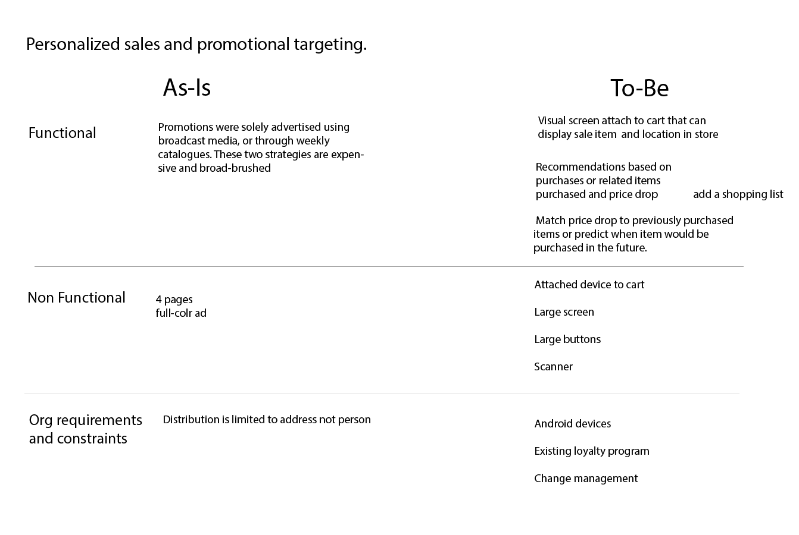

Edited by [Tommi Tyler](https://canvas.stanford.edu/courses/122184/users/283784) on Nov 9 at 10:33am

Data in:

Inventory

Item on sale

POI data - related items purchased to find trends

Customer purchase history (loyalty program data)

-Customer segment data

age, race, location

-item purchased

-frequency

-related item

-most frequently purchased brand

Potential data sets purchase

Recipes

MVP:

based on customer loyalty purchases we can recommend the same or related item that is on sale and point them to the item in the store.

Customer enters phone number into device

* Recommendations populate the screen with either
* Sale item from previous purchase and or related item on sale
* Location of sale item in store
* Recipe recommendation with other related items

As a user, I want to enter my phone number and my previously purchased items pictures populate my shopping list.

As a user, I want a way to add related pictures of items to my shopping list

As a user, I want to add sale items to my shopping list

As a user, I want to create a shopping list from previous purchased items

As a user, I want to find related recipes items

As a user, I want to add recipe items I choose to my shopping list.

As a user, I want to find my grocery list items located on the shelf.

# HealthTech Industry

**Industry: This is a New Product in HealthTech Industry**

**Team Members**: Ruchika Julka, Shelley Lineham, Eman Smadi

**The problem our team is currently working on solving:**

PPE compliance (and compliance reporting) in healthcare settings is currently being done manually and using best efforts which is not sustainable or scalable.

**Background:**

This pandemic has brought the world to a standstill. Economies have shut down, and cities have come to a crawl. What is clear is that COVID will continue, and even after a vaccine there will continue to be multiple challenges with virus containment.  In addition to life lost, healthcare workers themselves are put at risk which leads to a shortage of workers during urgent times. Additional costs are realized as patients require more investigations, longer stays in hospitals and additional treatments.

Our solution leverages deep learning techniques, coupled with existing infection control protocols to better safeguard healthcare workers through technology enabling pre-screening protocols. This solution would enhance and automate portions of PPE compliance reporting while keeping human healthcare screeners safer by pre-screening patients so appropriate additional pre-cautions can be taken when needed.

With enhanced compliance reporting, we can learn what specific protocols, when rigorously followed, can have the best health outcomes.

* **Week 3 homework starts here**

As Is/To Be - patient

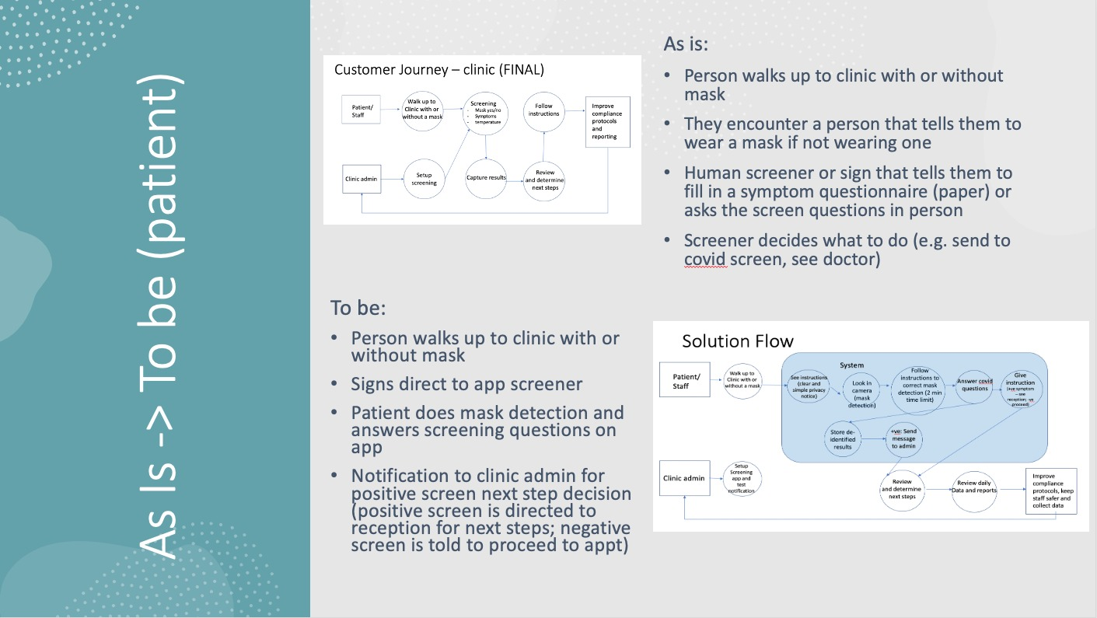

As Is/To Be - clinic

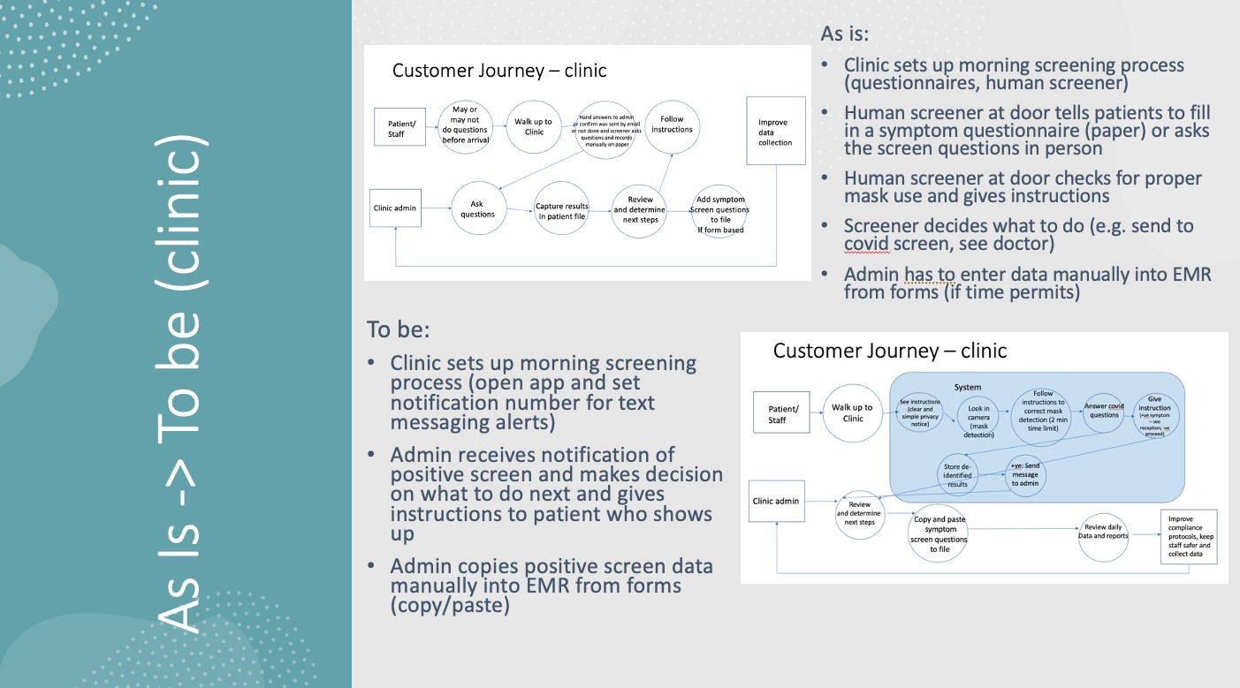

As Is/To Be - Industry

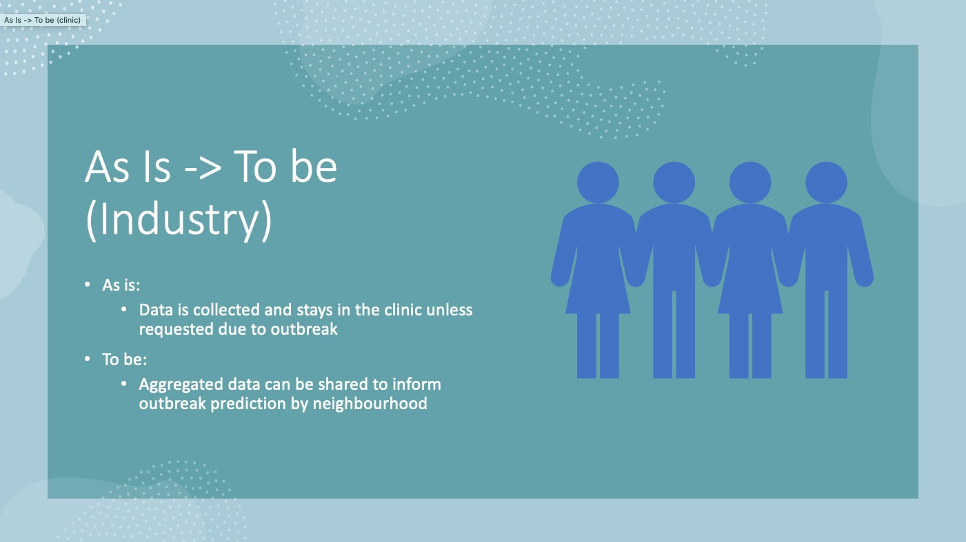

[Shelley Lineham](https://canvas.stanford.edu/courses/122184/users/285573)

## [Shelley Lineham](https://canvas.stanford.edu/courses/122184/users/285573)

Oct 25, 2020Oct 25 at 11:24am

[Manage Discussion Entry](https://canvas.stanford.edu/courses/122184/discussion_topics/531178)

Prioritized features for MVP:

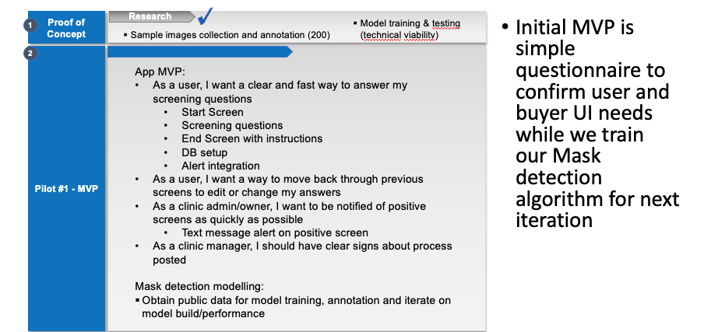

Backlog with priority:

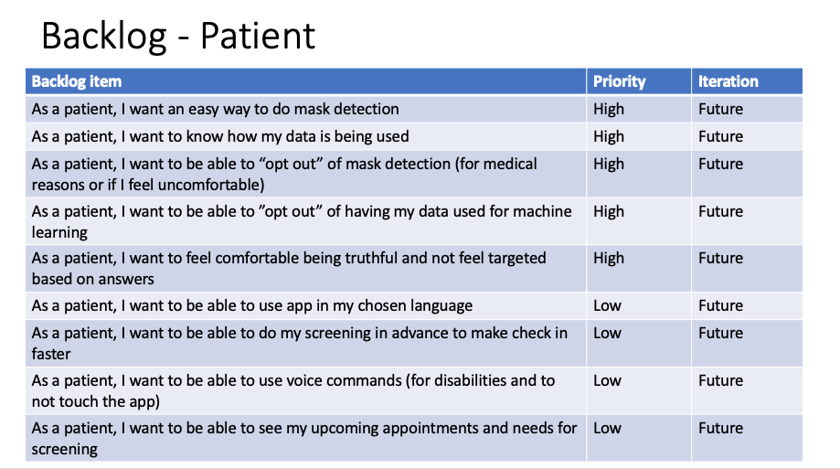

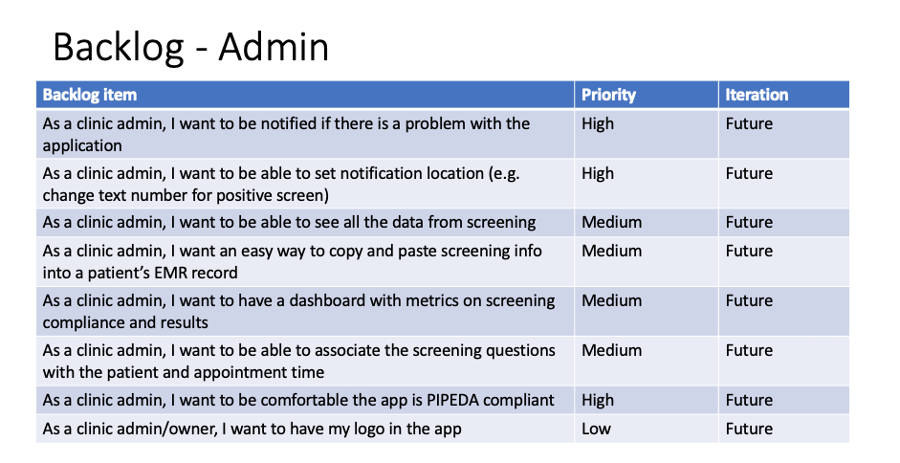

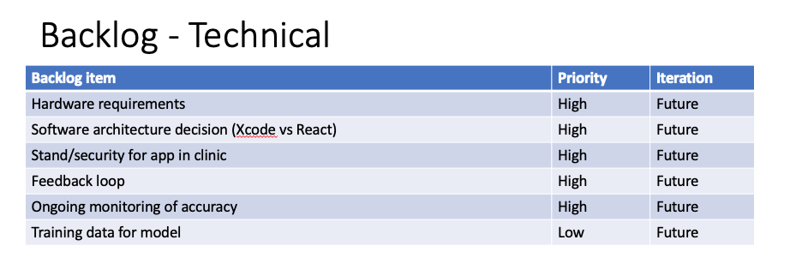

[Shelley Lineham](https://canvas.stanford.edu/courses/122184/users/285573)

## [Shelley Lineham](https://canvas.stanford.edu/courses/122184/users/285573)

Oct 25, 2020Oct 25 at 11:25am

[Manage Discussion Entry](https://canvas.stanford.edu/courses/122184/discussion_topics/531178)

AI Solution Reseach (based on p 39):

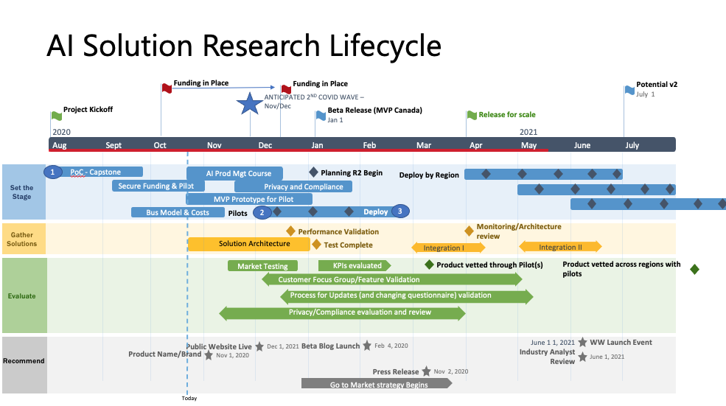

[Shelley Lineham](https://canvas.stanford.edu/courses/122184/users/285573)

## [Shelley Lineham](https://canvas.stanford.edu/courses/122184/users/285573)

Oct 25, 2020Oct 25 at 11:27am

[Manage Discussion Entry](https://canvas.stanford.edu/courses/122184/discussion_topics/531178)

KPIs:

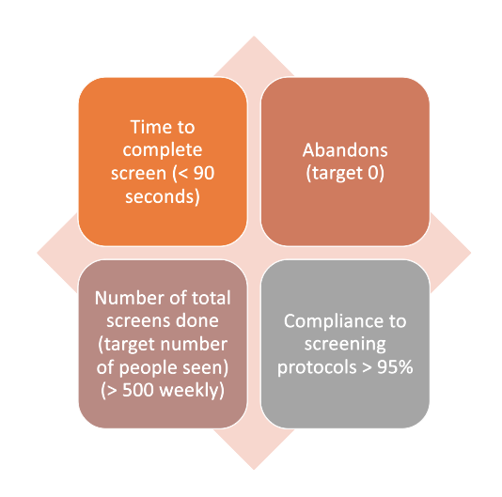

Constraints:

* + Needs to be technically simple (grade 1 level) for use by all ages/reading levels
  + PIPEDA compliance
    - [https://www.priv.gc.ca/en/privacy- (Links to an external site.)topics/privacy-laws-in-canada/the-personal-information-protection- (Links to an external site.)and-electronic-documents-act-pipeda/pipeda-compliance- (Links to an external site.)help/pipeda-compliance-and-training-tools/pipeda_sa_tool_200807/ (Links to an external s](https://www.priv.gc.ca/en/privacy-topics/privacy-laws-in-canada/the-personal-information-protection-and-electronic-documents-act-pipeda/pipeda-compliance-help/pipeda-compliance-and-training-tools/pipeda_sa_tool_200807/)

# HIPPA compliance if moving into US

Oct 25 at 8:36pm

[Manage Discussion Entry](https://canvas.stanford.edu/courses/122184/discussion_topics/531178)

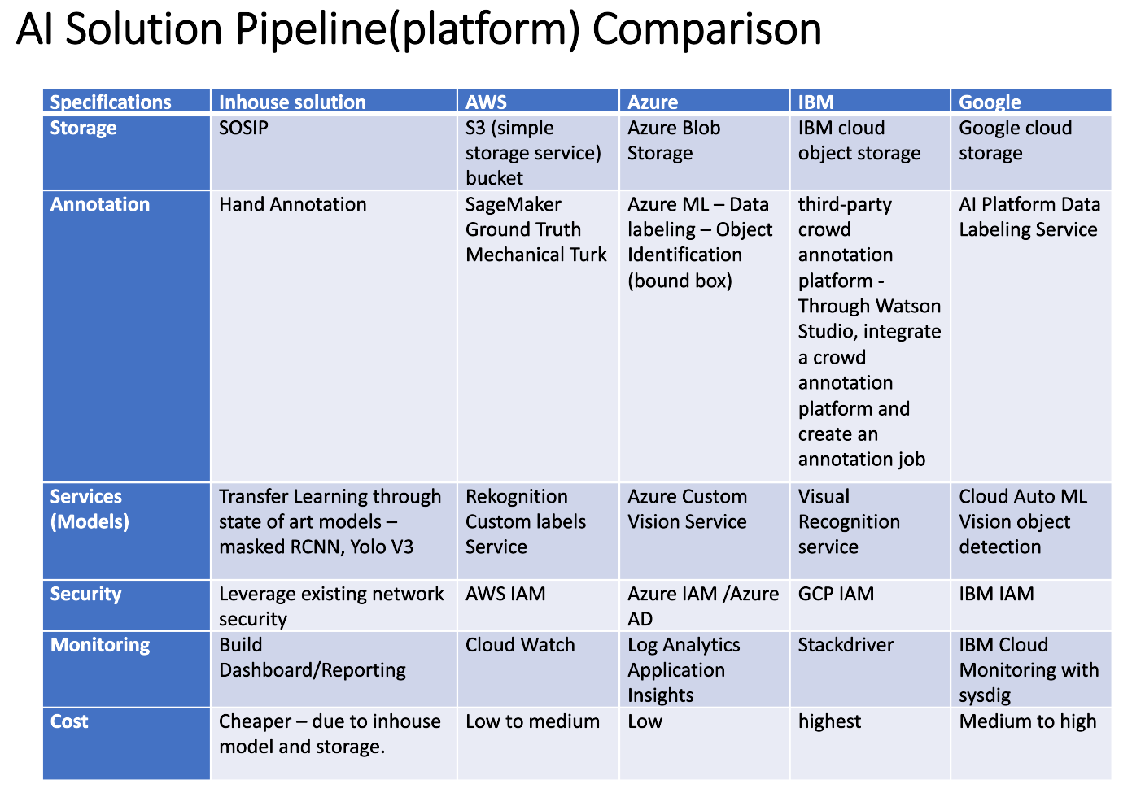

Hello Prof,

For our Prototype, we have decided to go with an in-house solution for the following reasons:  
1. We have funded storage space, if we decide to go with any cloud provider it will be an added cost.  
2. We have some experience with AWS required services but will have a learning curve for all other cloud providers.  
3. Since we have a data scientist who has good knowledge in using deep learning models(transfer learning technique), a freelance developer and designer; we should be able to quickly prototype.   
4. Hand annotation from the team members for the prototype should be enough.  
5. The security is covered with the funded storage space.  
6. We have experience and will leverage plotly dash (free tool for building dashboard quickly using python) for prototyping.  
7. Overall cost will be much lower with an in-house option

Industry: Finance

Problem: How do we allocate the right amount of capital to each client?

Background: credit adjudication has to balance client needs, client capacity, and FI constraints (maximum capital extended, risk profile) - how do we optimize the portfolio?

**Industry: Fintech**  
Team Member: Kishore Kesanapally

Problem Description (User Story):

Collections Cease and Desist"

Customers are struggling with debt frequently contract with debt settlement companies who then send a cease and desist letter to end collections contacts, which usually results a loss on debt for fintech company.

Acceptance Criteria: This model is like to identify customers likely to resort to cease & desist. Used to identify possible debt settlement company customers so that fintech company can offer an assistance.

Business Value:

Elimination of cease & desist customers should reduce debt charge off by at least 2% annually in cease & desist services. A 2% reduction is multimillion dollar savings to fintech company.

Homework 1:

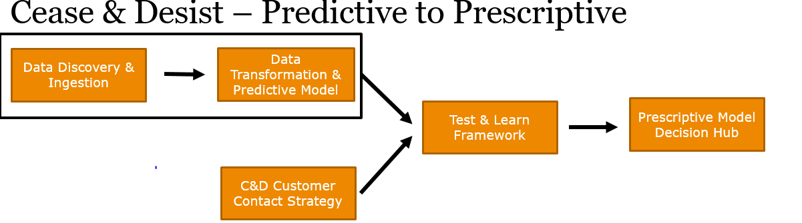

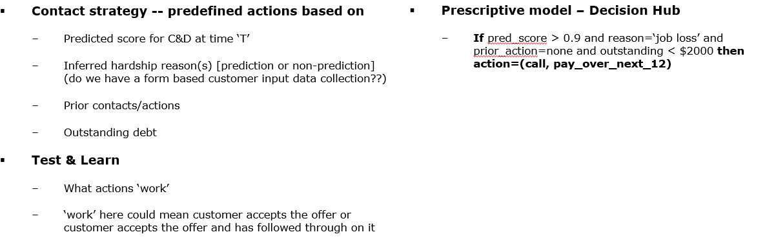

Homework2:

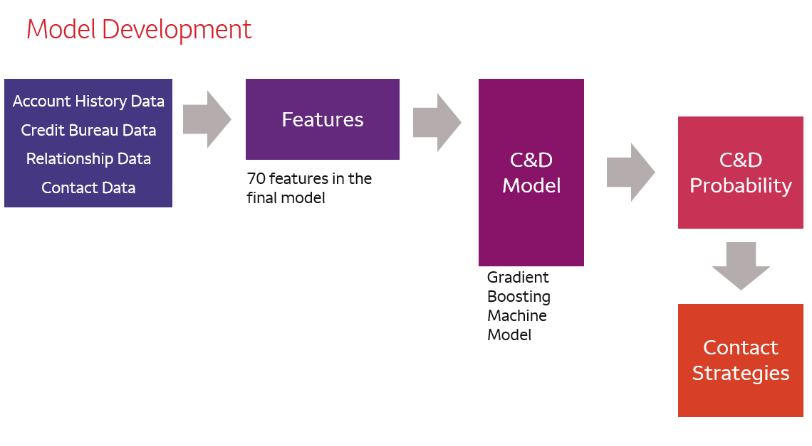

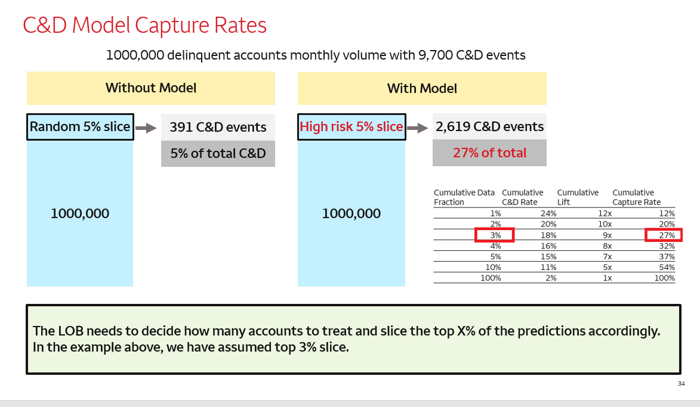

**Problem Description**

**Industry:** Finance

**Domain:** Personalised Financial Wellness B2C

**Sub-domain:** Simplify financial decisions for Customers

**AI Opportunity:** Building a neo-banking product that covers all dimensions of money – spends, savings, investments, payments, loans, insurance and taxes

**Background:** Decision making related to Money is not easy for many people and high quality Advice is not easily available. With success of FinTech, people money is widely distributed and it is getting difficult to know what I have, what I owe and what I need.

**Product Opportunity:** Aggregating customer finances in highly secure way (with strong compliance to data privacy norms), delivering deep financial insight in easy to consume manner, provides with smart recommendations and has seamless execution to implement the advice. Using the platform, customer can manage their spends, increase their savings, make timely payments, borrow right, enable intelligent investments, ensure right insurance and get holistic tax advice.

**Why AI?** Bringing together behavioural science, financial science and advanced technologies. Training on financial knowledge, customer's financial queries and conversations and will expertly guide the customer through the entire spectrum of financial products - thus creating a single platform for all financial needs of the customers.

**Problem Description:**

**Ideal:** Conversational AI driven Financial Companion able to understand customer's overall finances - income, expenses, savings, investments. Give insights on their data future financial transactions, ideal retirement corpus, insurance needed, handle user personal financial goals.

**Reality:** Currently, customers's finances are distributed all over the place and different platforms. Recommendations given are not on the basis of overall financial profile of the customer. Chatbots are able to answer queries from one domain, but are not efficient enough in combining aggregated insights and using these insights to recommend further products to the customers.

**Consequences:** The current strategies in the market tries to recommend different financial products to the customers based on what company wants to sell. But not what is best for customer's profile. Leading to degrading customer experience or not able to recommend the right products for them.

**Proposal:** To build a financial wellness chatbot aimed to analyse historical financial transactions and data of the customers understanding and predicting future transactions of the customers based on their profile. Recommending the right solution which is optimal to the customer based on their personal expenses, income, savings and investments. The solution has to analyse every incoming, outgoing transactions, read their financial statements, perform analysis on their historical data, create insights using customer's historical data. Recommending optimal insurance, investment, loan products to the users using these insights generated.

**Map: Understand Long Term Goals:**

To understand the user’s area/domain of interest based on profile features - age, income group, gender, location etc.  
To aggregate all the financial data of the users from different sources under one umbrella.  
To present the daily/weekly/monthly insights to the users about their financial transactions and patterns.  
To automate understanding user's historical data and behaviour patterns in fixed intervals.  
To recommend custom financial products to the users based on the financial insights generated.  
To validate if the insights given are relevant and useful to the customer.  
To handle goal driven conversational flows

**Sprint Questions:**

How to align to user's data and compliance guidelines.  
Building trust factor in the user before handling their financial data. Is the brand name needs to be established before doing this?  
Handling scope creep, since the goal is to aggregate all finances of the users.  
How to do the prioritisation over different financial domains. Is doing a customer survey or research a good way to approach this problem?  
Gathering relevant financial data, products data to build models for questions answering, recommending different financial products.

**Industry: Legal and Finance**

**Problem Statement:**  Using Artificial Narrow Intelligence(ANI) Summarizing online end-user license agreement (EULA) to a format where customers can make an informed decision based on the local laws and contrasting it with the agreement that is being presented.

**Sprint Map :**

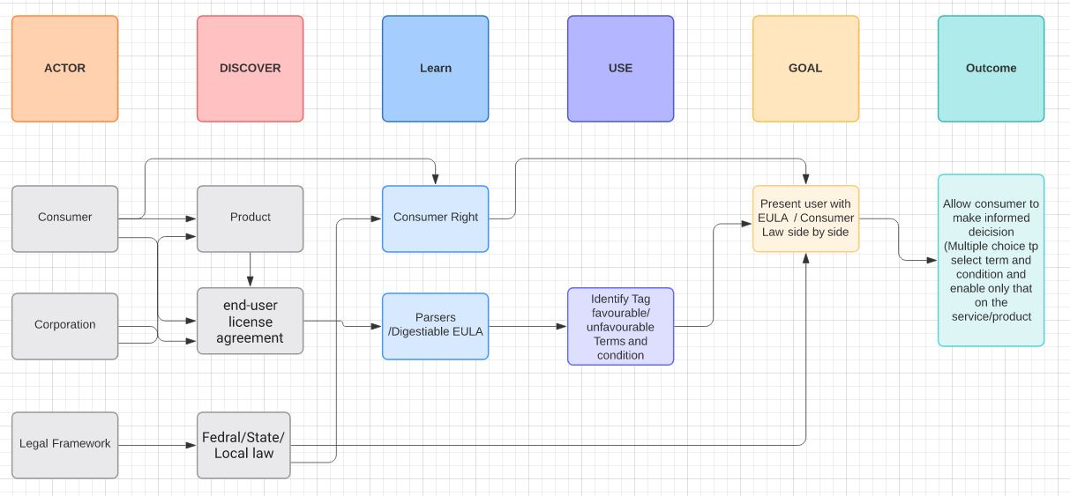

**AI opportunities:**

We have an opportunity to educate the masses both on the legal front and safeguard them to get into accepting terms and conditions, which may not be favorable both from a financial and ethical viewpoint. It will also allow the consumer to understand their legal rights.  This presents an automation opportunity, where extensive legal documentation can be present in a digestible format.

**Home Work 02 :**

* Buyer's Utility Map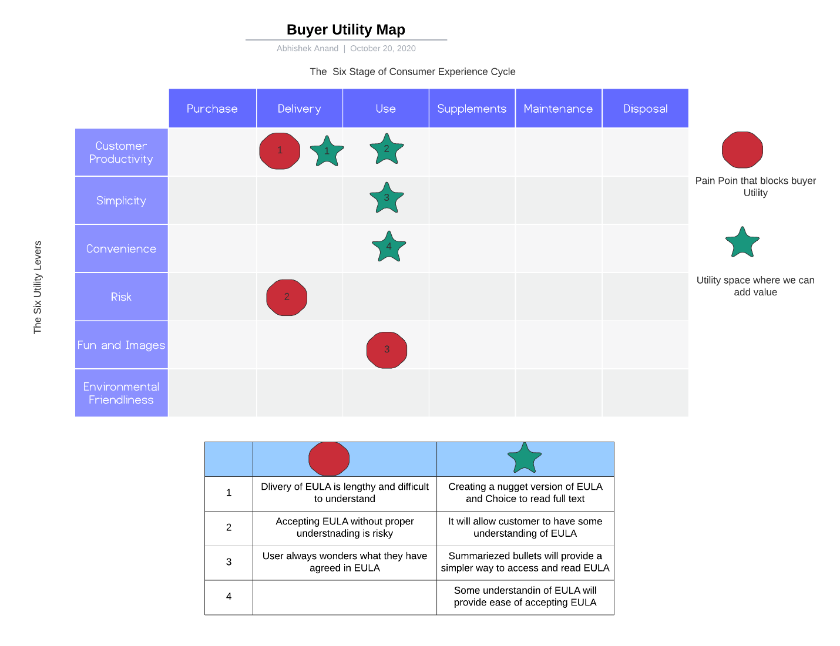
* Empathy Map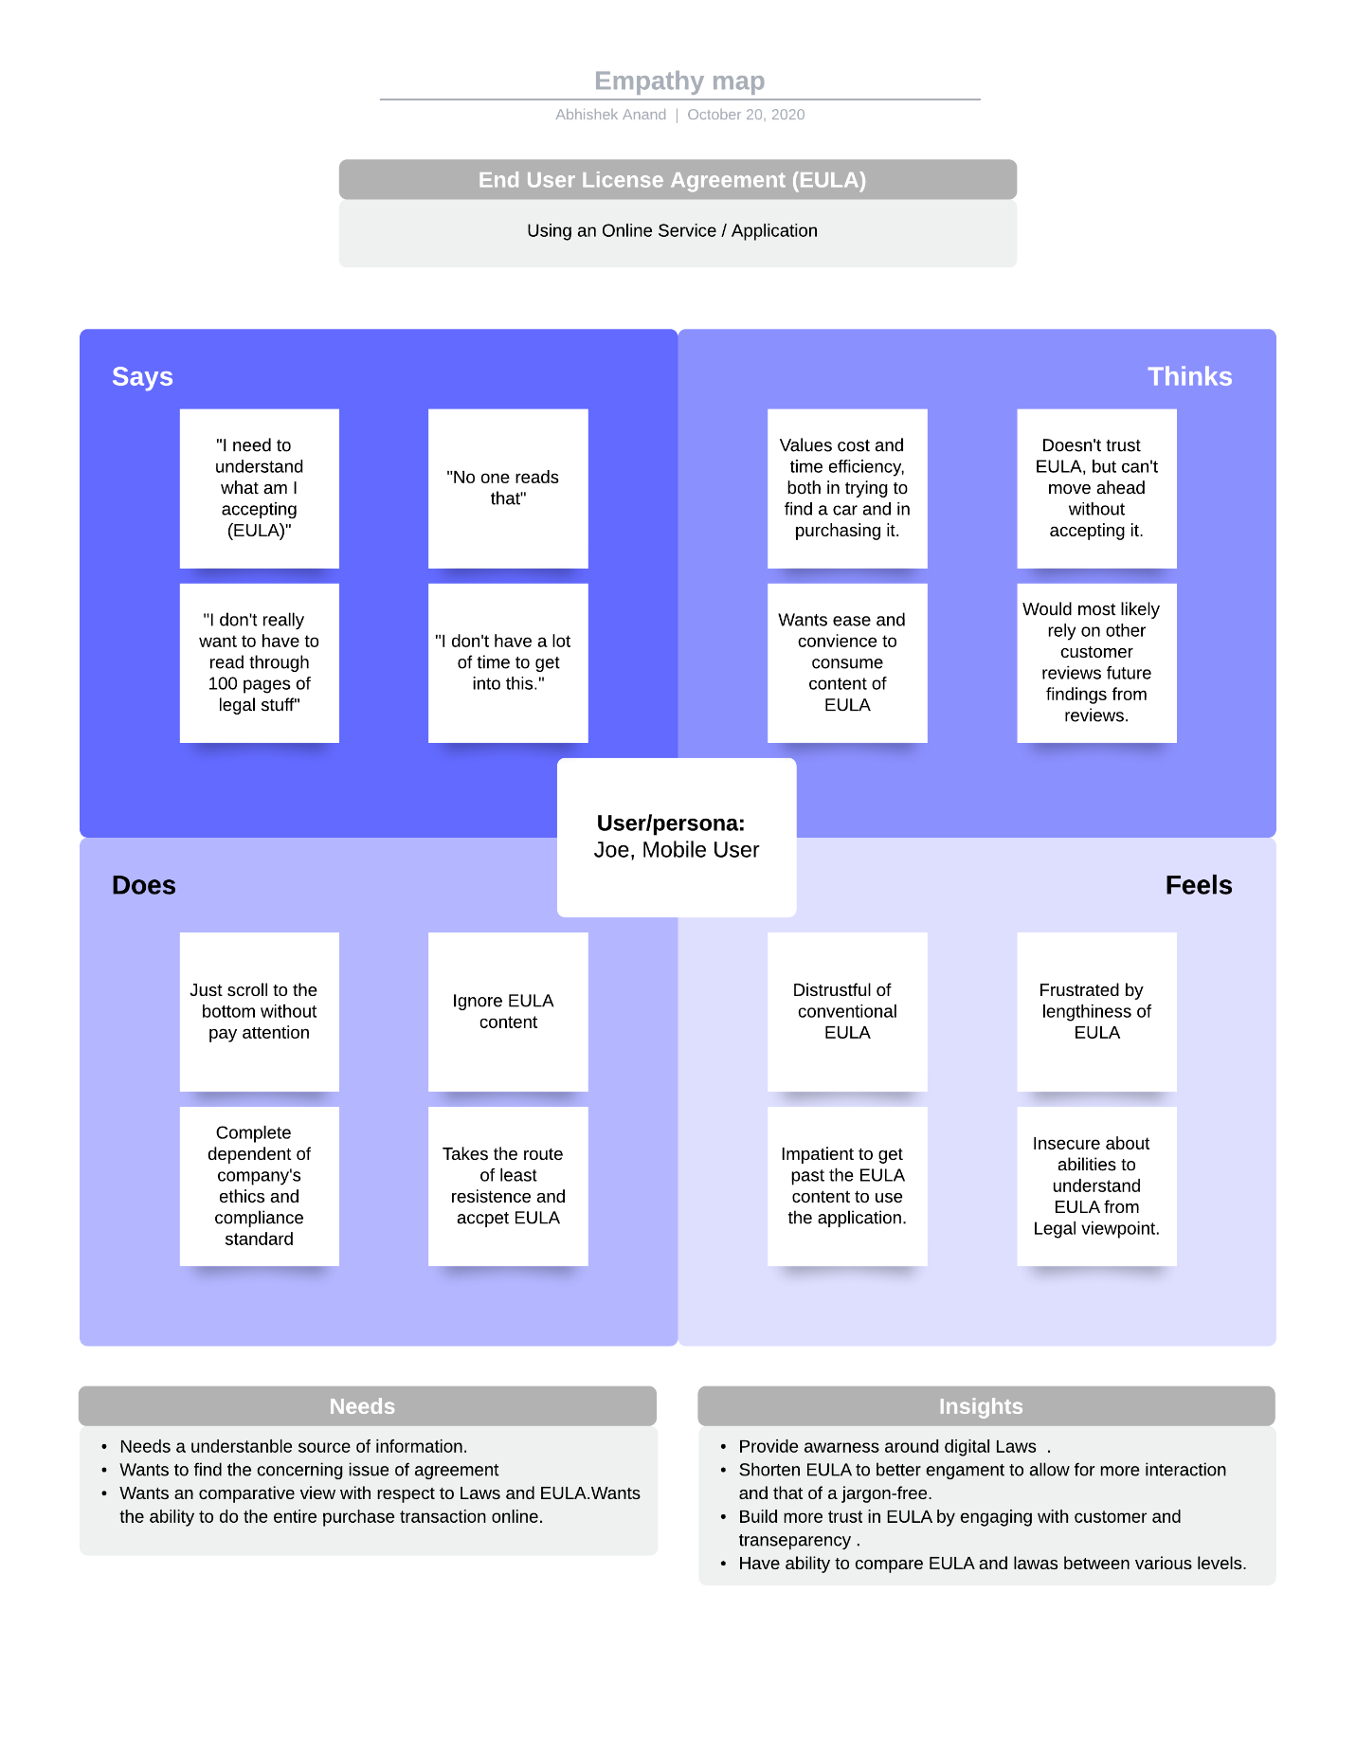
* Four actions framework

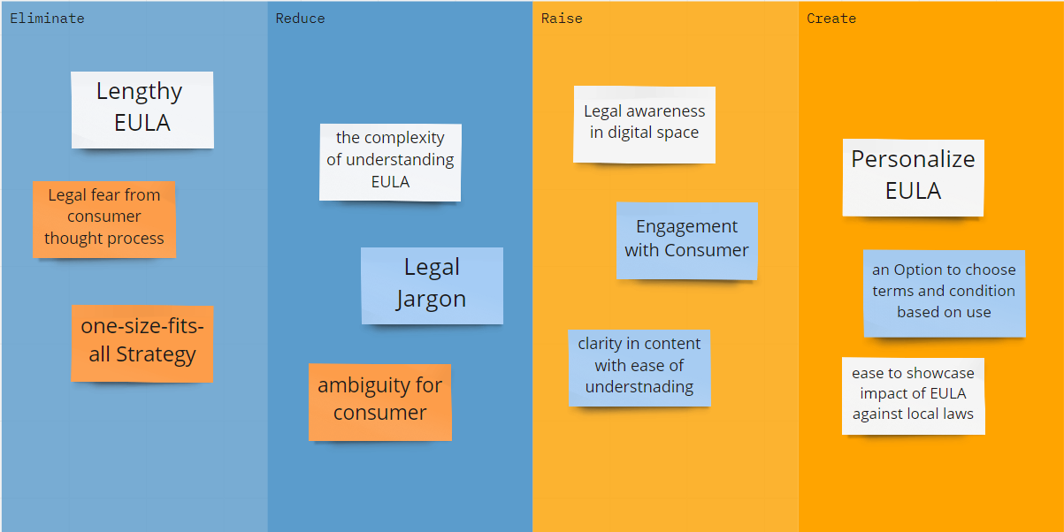

How might we summarize legal documentation so that users can make an informed decision about financial products?

This problem is trying to capture EULA in a broader perspective, where fintech products are one aspect of the problem. Your question is quite valid, and that is what I am trying to explore.

Does that count as informal legal advice?

In the earlier version, not, really. This will be more of the summarized nuggets provided to the user for the EULA presented to them so they are somewhat informed as to what they are accepting. For legal advice, the product might need to be backed up by legal representation, which can be a business model.

Is there risk to your company?

Indeed, as this quite an uncharted space where technology will be exploring legal space.

Local, State and federal laws are complicated.

The idea is that either law at various levels will converge or diverge. When we are focusing on a written set of agreements, we should be able to parse that out against established laws.

This is still a concept as per the information/knowledge economy, whereas a user I can get some idea before accepting 100 pages of digital EULA.

ndustry: Finance

* The business challenge/question: Product forecasting in a big organization is done at numerous levels across the organizations. Regional forecasts vary from global forecasts due to confidence in assumptions and need for segmentation of forecasts. While this suits the forecast originator, this ends up generating many different versions and are subjected to a lot of manual changes. Forecasts are difficult to compare leading to lack of clarity for C-suite.
* Impacts on business: This forecasting process will allow the finance teams to have clearer vision into the behavior of sales of our products and countries and enable relevant data-driven decision-making. Additionally, this process can be robust, modular and replicable with opportunity to becoming the the gold standard forecasting framework across the company.
* AI opportunity: An automated algorithm that can analyze properties of each sales trend and determine what type of machine learning or time series method will produce most accurate and precise forecast. Deploy the algorithm company-wide such that it can produce with every data refresh.

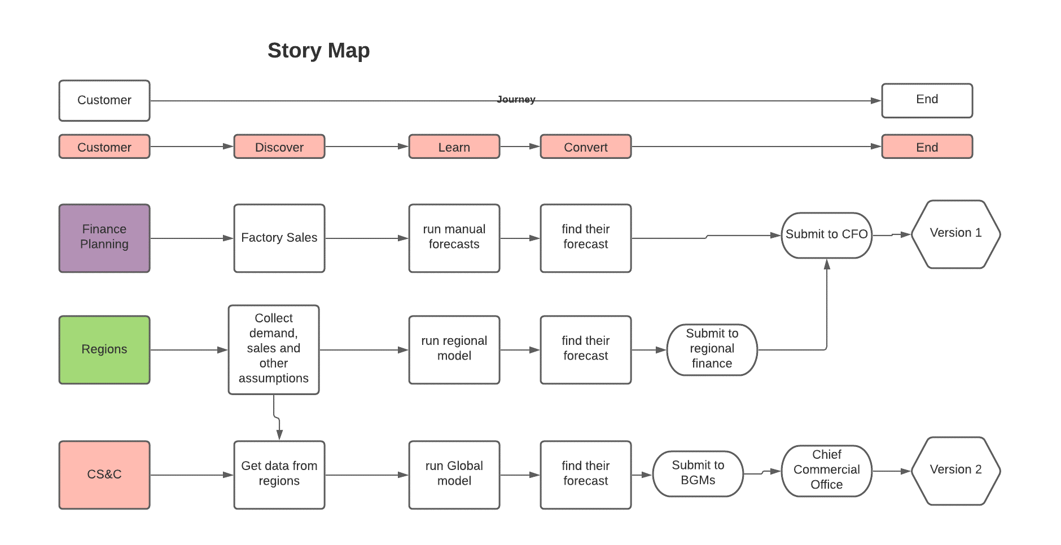

Akansha Saxena: HW2

Buyer Utility Map

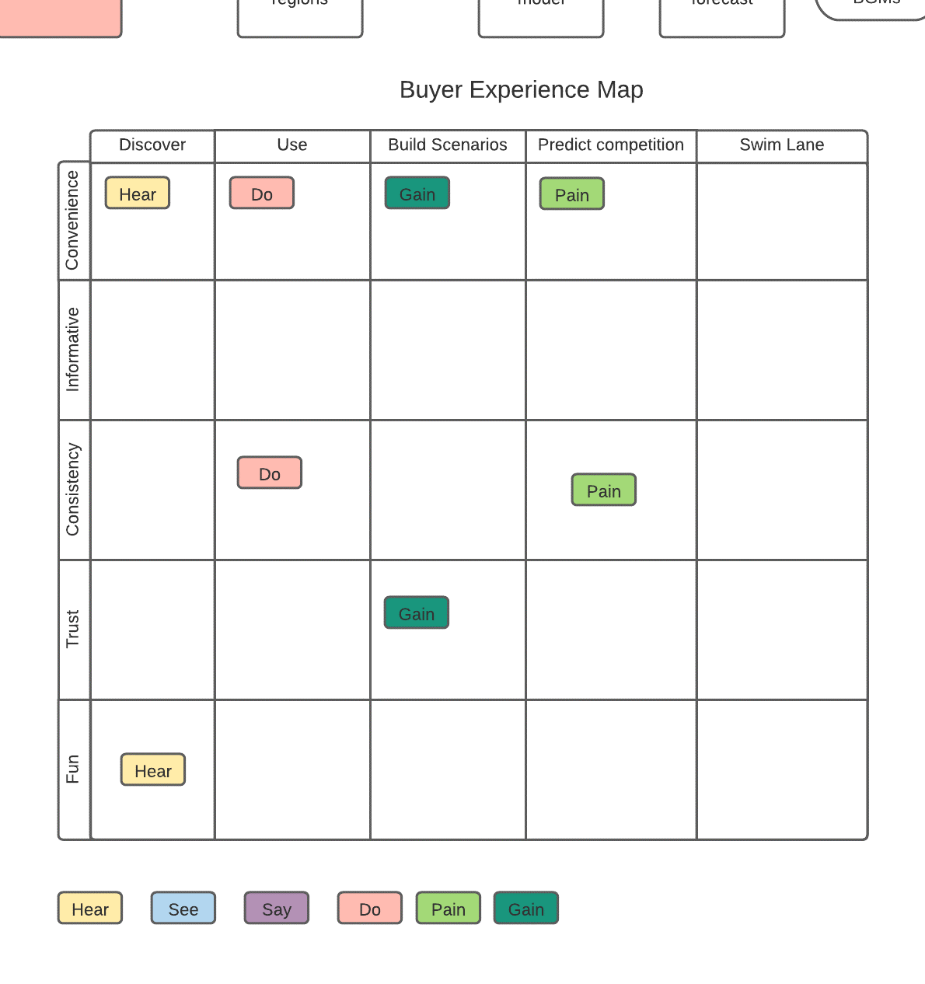

Four Actions Framework

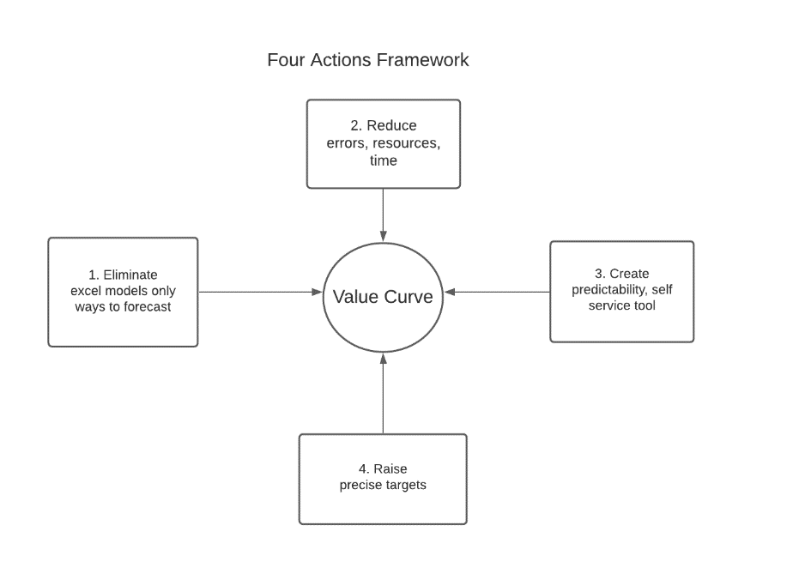

Akansha Saxena: HW3

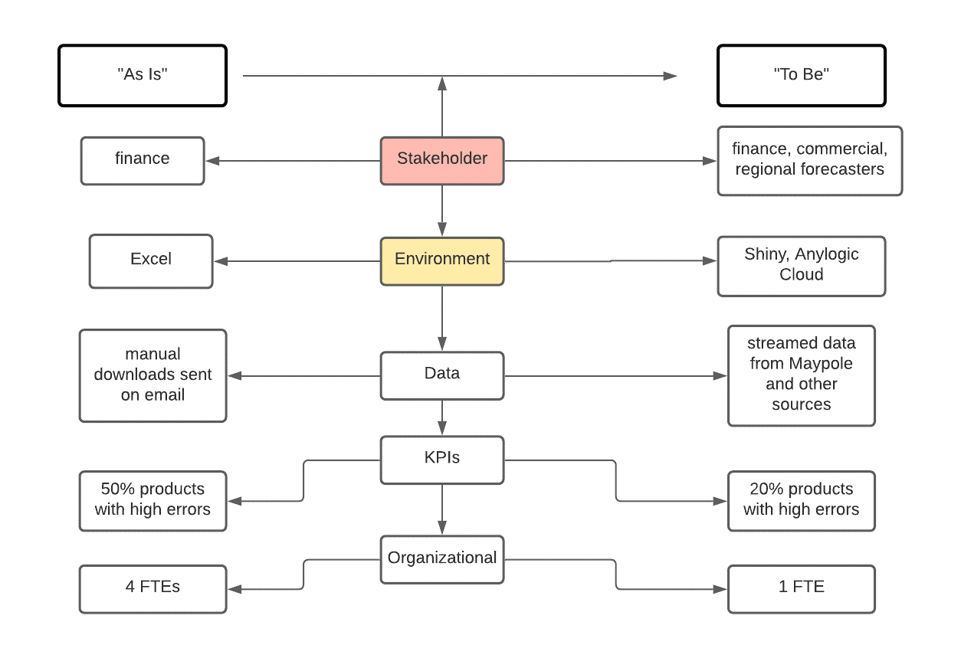

**Data Science Interaction**

Storyboard:

Record of what I usually buy is known

I am alerted when my item or new item goes on sale

When I walk into store my application is active and I can now get notice that I am close to sale item

I can use VR application to see my path to the item

I can check items off my list

If it is a fresh item I can use my phone to see how fresh the item is

I can see how much money I am saving if I buy this item

I leave the store a happy customer

KPI:

Number of sale items purchased

Number of users signed up use app and VR Feature

Number of times the alert for close proximity to sale item

# Manufacturing/ Process Industry

Goal: To increase uplift and yield of clean coal with specific ash and moisture content.

Storyboard:

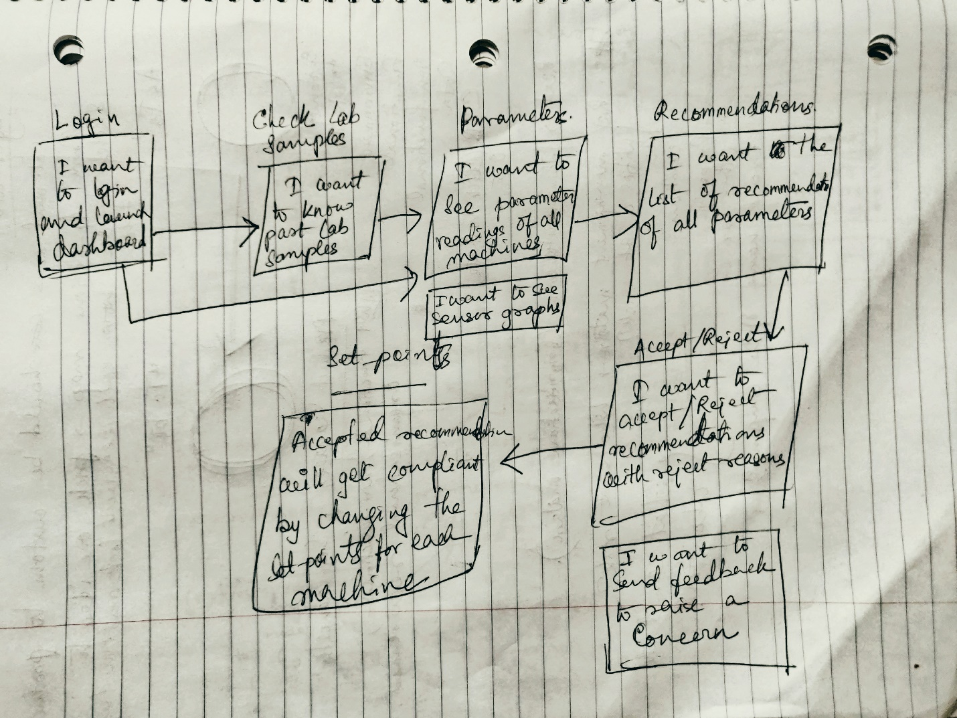

KPI:

* Amount of Uplift of clean coal
* Amount of yield of clean coal
* Number of accepted and compliant recommendations
* Solution availability

Constraints:

* The granularity of data due to lack of enough sensors
* Ash and moisture lab samples take 1.5 hours to get logged into the system

[Sayanti Ghosh](https://canvas.stanford.edu/courses/122184/users/281335)

## [Sayanti Ghosh](https://canvas.stanford.edu/courses/122184/users/281335)

Oct 24, 2020Oct 24 at 7:37pm

[Manage Discussion Entry](https://canvas.stanford.edu/courses/122184/discussion_topics/537481)

Data science solution proposal( I am using my Data Science background for the proposal post discussion with one of my colleague)

HLD:

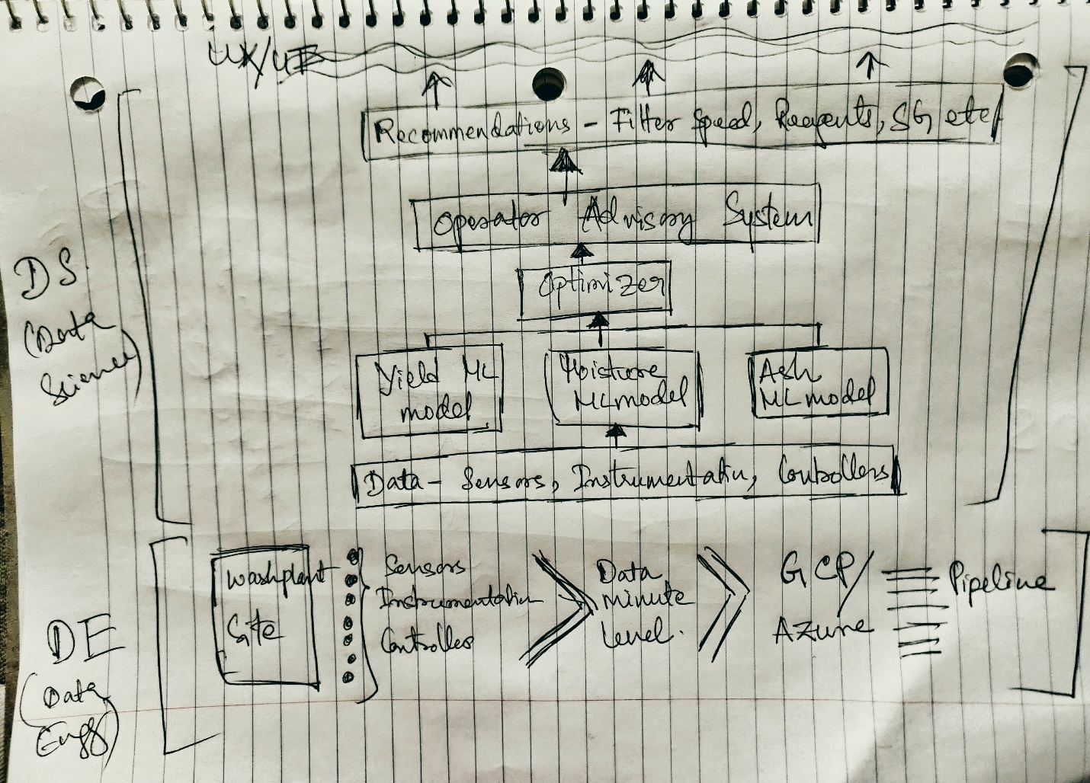

Data Exploration:

* + Sensor data,
  + Instrumentations data,
  + Controller data

Granular the better so data to sec level or at least min level is required

With given sensors in place need to check how much of the data is missing. Either forward filling of missing data or mean/median filling. Outliers to be removed and the balance of data should be checked. Correlation of parameters should be checked and highly correlated features to be removed and post feature engineering, feature importance to be checked to decide topmost 20 features with the highest impact on uplift and yield.

Model Proposal:

Three models for prediction, the primary constraint is ash and moisture so predictive model of ash and moisture. Using plant feed as a constraint for Yield predictive model (as yield increase has no constraint, and plant feed increment has constraint).

Thre predictive model: Yield, ash, moisture

There will be a trade-off between accuracy, the sensitivity of the model. As we want to have more controllable parameters as important features for recommendations. Having a non-controllable feature for recommendations will not make any difference as those cannot be controlled by operators.

All the predictive models will be used by an **optimizer** which will generate the recommendations by calculating the last 4-hour average and connecting the ash and moisture target as constraints.

Output:

For the topmost 20 features, recommendations of set-points will be generated every 4 hours.

[Eman Smadi](https://canvas.stanford.edu/courses/122184/users/285572)

## [Eman Smadi](https://canvas.stanford.edu/courses/122184/users/285572)

Oct 25, 2020Oct 25 at 1:11pm

[Manage Discussion Entry](https://canvas.stanford.edu/courses/122184/discussion_topics/537481)

# ****Team 1 - HealthTech Industry****

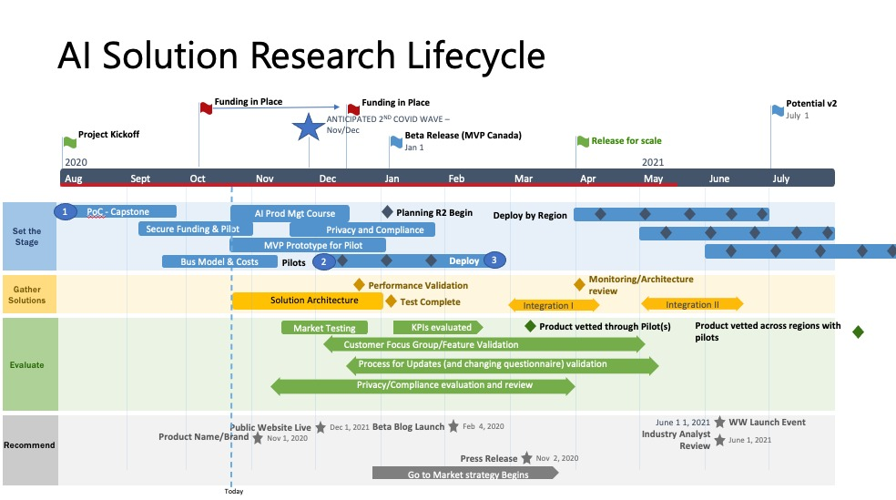

**Goals:**

* + The goal of this business is to chart out a path to profitability in the first 3 months. This will be done through conversations with both clinic owners and the government to establish the target payer for the service.
  + The goal of this business is to have 5 active pilot customers by the end of 3 months.
  + The goal of this business is to remain below 90 seconds for each covid screening through the application.
  + **The overall goal is to accurately measure compliance to screening protocols and improve screening adherence (goal of > 95%)**

**Storyboard:**

* + The first iteration will be symptom checking only (no AI) to get the right user experience and process before we integrate our algorithm for mask detection
  + Limited data collection to pre-empt privacy concerns while checking the adoption rate is sufficient
  + Admin is unclear what they want in dashboards, by spending less time building them in MVP, we can using the prototype to build out faster-reporting iterations for quick feedback.

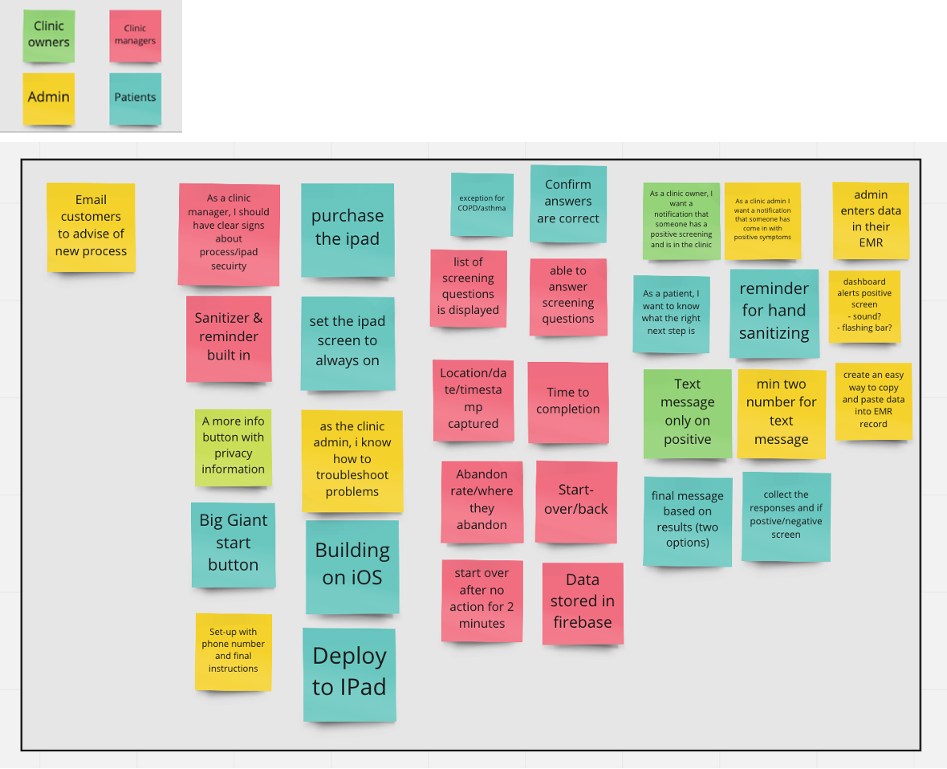

**KPIs:**

* + Time to complete screen (< 90 seconds)
  + Abandons rate (target 0)
  + Number of total screens done (target number of people seen) (> 500 weekly)
  + Compliance to screening protocols > 95%

**Constraints:**

* + PIPEDA compliance  [https://www.priv.gc.ca/en/privacy-topics/privacy-laws-in-canada/the-personal-information-protection-and-electronic-documents-act-pipeda/pipeda-compliance-help/pipeda-compliance-and-training-tools/pipeda_sa_tool_200807/ (Links to an external site.)](https://www.priv.gc.ca/en/privacy-topics/privacy-laws-in-canada/the-personal-information-protection-and-electronic-documents-act-pipeda/pipeda-compliance-help/pipeda-compliance-and-training-tools/pipeda_sa_tool_200807/)
  + HIPPA compliance if moving into USA
  + Data Privacy Statement link on the front screen with an “opt-out” box for use of data in training machine learning algorithms

**Data Acquisitions:**

***Data needed for Screening:***

* + Images for Mask yes/no (acquire from public sources) Ideal breakdown below
    - Images of faces with mask (50% of total image count)
      * Blue mask  20%
      * White mask 20%
      * Green masks 20%
      * Black masks 20%
      * Cloth masks (various styles and colours) 20%
    - Images of faces without mask or improper mask (50% of total image count
  + Answers to screening question:(collected in-house)
    - Fever
    - Fatigue
    - Cough/breathing issues
    - Travel in the last 14 days
    - Loss of taste or smell
    - Headache
    - Runny nose/sneezing (non-allergies)
    - Contact with confirmed or suspected COVID-10
  + Kaggle datasets found:
    - 550 with masks
    - 550 without
    - [https://www.kaggle.com/prithwirajmitra/covid-face-mask-detection-datase (Links to an external site.)](https://www.kaggle.com/prithwirajmitra/covid-face-mask-detection-dataset)
    - [(Links to an external site.)](https://www.kaggle.com/prithwirajmitra/covid-face-mask-detection-dataset)[https://www.kaggle.com/sshikamaru/face-mask-detection (Links to an external site.)](https://www.kaggle.com/sshikamaru/face-mask-detection)
    - [(Links to an external site.)](https://www.kaggle.com/sshikamaru/face-mask-detection)[https://www.kaggle.com/serkanpeldek/face-detection-with-opencv (Links to an external site.)](https://www.kaggle.com/serkanpeldek/face-detection-with-opencv)

**Data Quality:**

***Accuracy***

* + Mask detection:
    - Use best in class transfer learning models for object detection (Yolov3 and Mask-RCNN)
    - Use balanced dataset for training
    - Split the data into train, validate, and test datasets (80% train, 20% test)
    - Use test data to measure results: Each image prediction by the average precision & mean average precision for total predictions
    - Split the data into train, validate, and test datasets (80% train, 20% test)
    - Use test data to measure results: Each image prediction by the average precision & mean average precision for total predictions
  + Screening Questions: Dependent on human honesty

***Consistency***

* + Watch for drift: allow for ”not required due to medical condition”
  + Use the data captured to retrain the model and allow for improvements
  + Simple interface will facilitate consistent data capture in the early stages

***Integrity & Validity***

* + Mask detection:
    - Data labeling is consistent with the problem (Mask, no Mask)
    - Data used for training are like the real-world problem (People Headshots)
  + Screening questions:
    - Consistent with the current process and validated by the clinic

***Timeliness & Completeness***

* + Due to the current COVID pandemic data is readily available
  + Images of people wearing masks
  + Screening questions

**Model Proposal - In-house Solution**

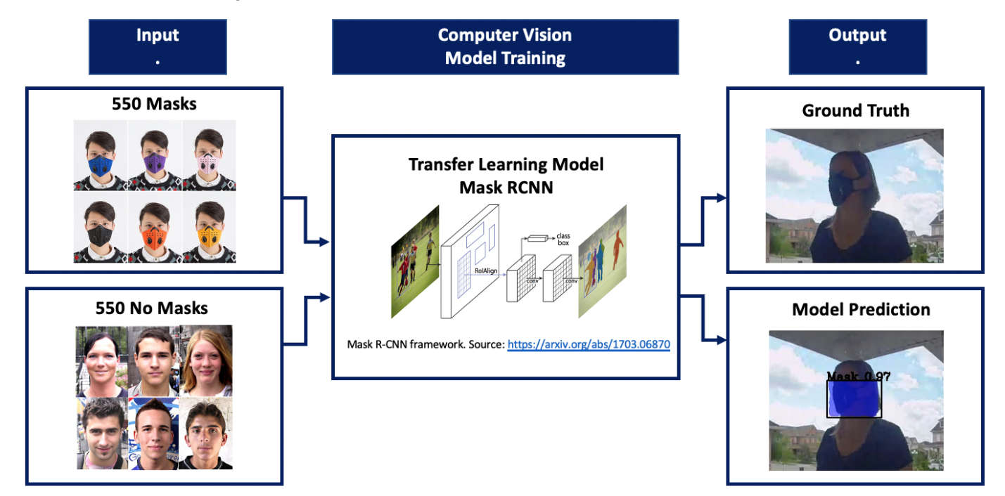

AI in Demand Forecasting

**Goals**

Provide demand forecasts for individuals items in retail stores in order to inform downstream logistics decisions such as replenishment and clearance pricing.

For example, the model will predict that Trader Joes store in Town & Country, Palo Alto will sell 100 units of Sriracha sauce (TJ’s own brand) in the week of Oct 25.

Subsequently, if say the supply in the store is below 120, TJ should replenish from vendors or distribution centers prior to the week.

**Storyboard**

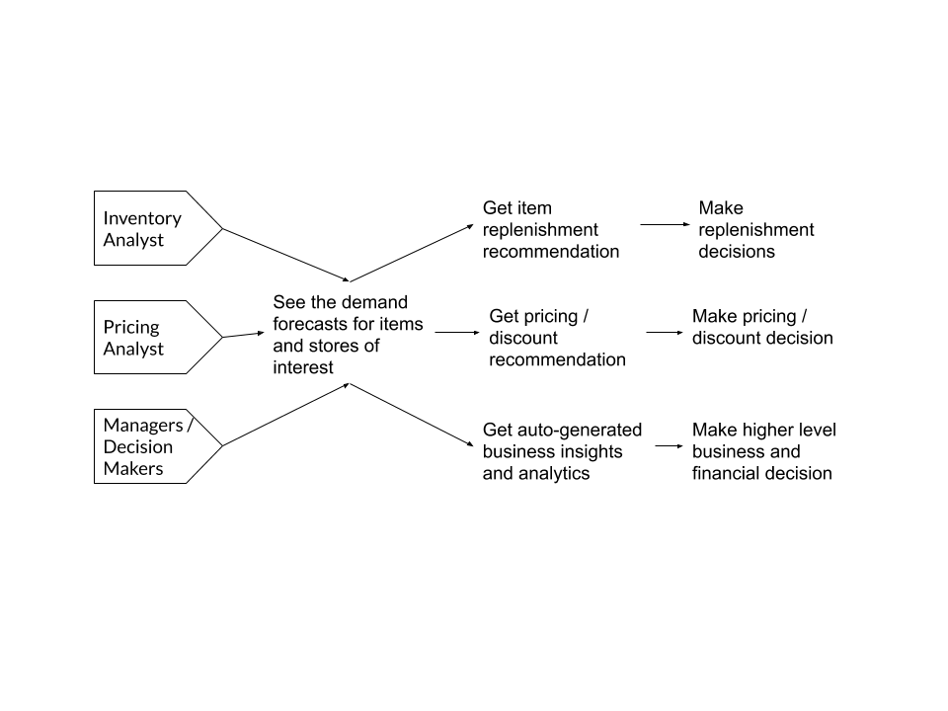

**KPIs**

4 main ones:

1) Accuracy of the prediction;

2) Scalability of the system (to support the entire organization);

3) Explainability of the models;

4) Timeliness of the outputs.

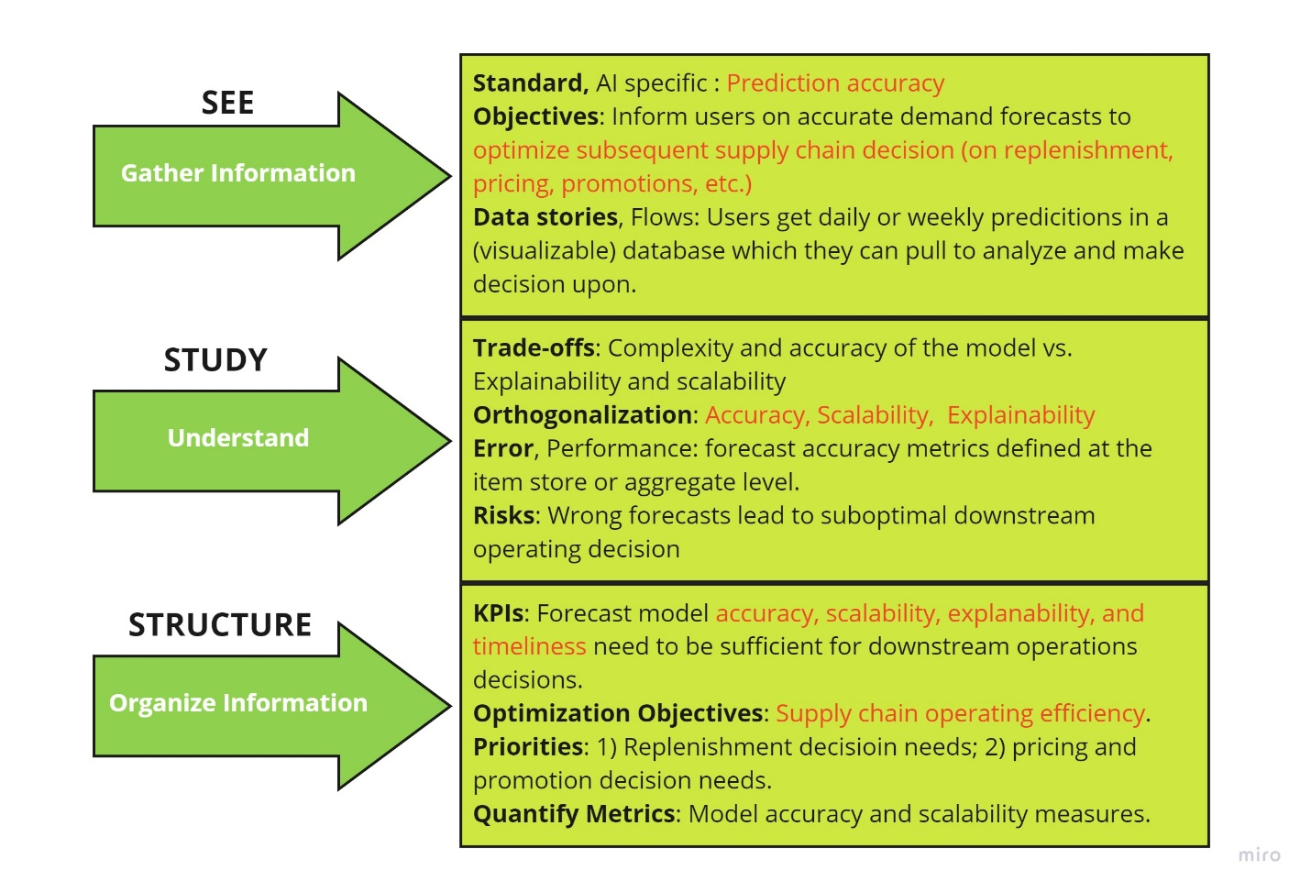

**Requirements Constraints**

1) Financial resources - ideally less than $10mm to build out the system

2) Organizational tech infrastructure constraints (for the purpose of the project, we can assume unlimited computing power for now).

More in "As Is" -> "To Be" analysis:

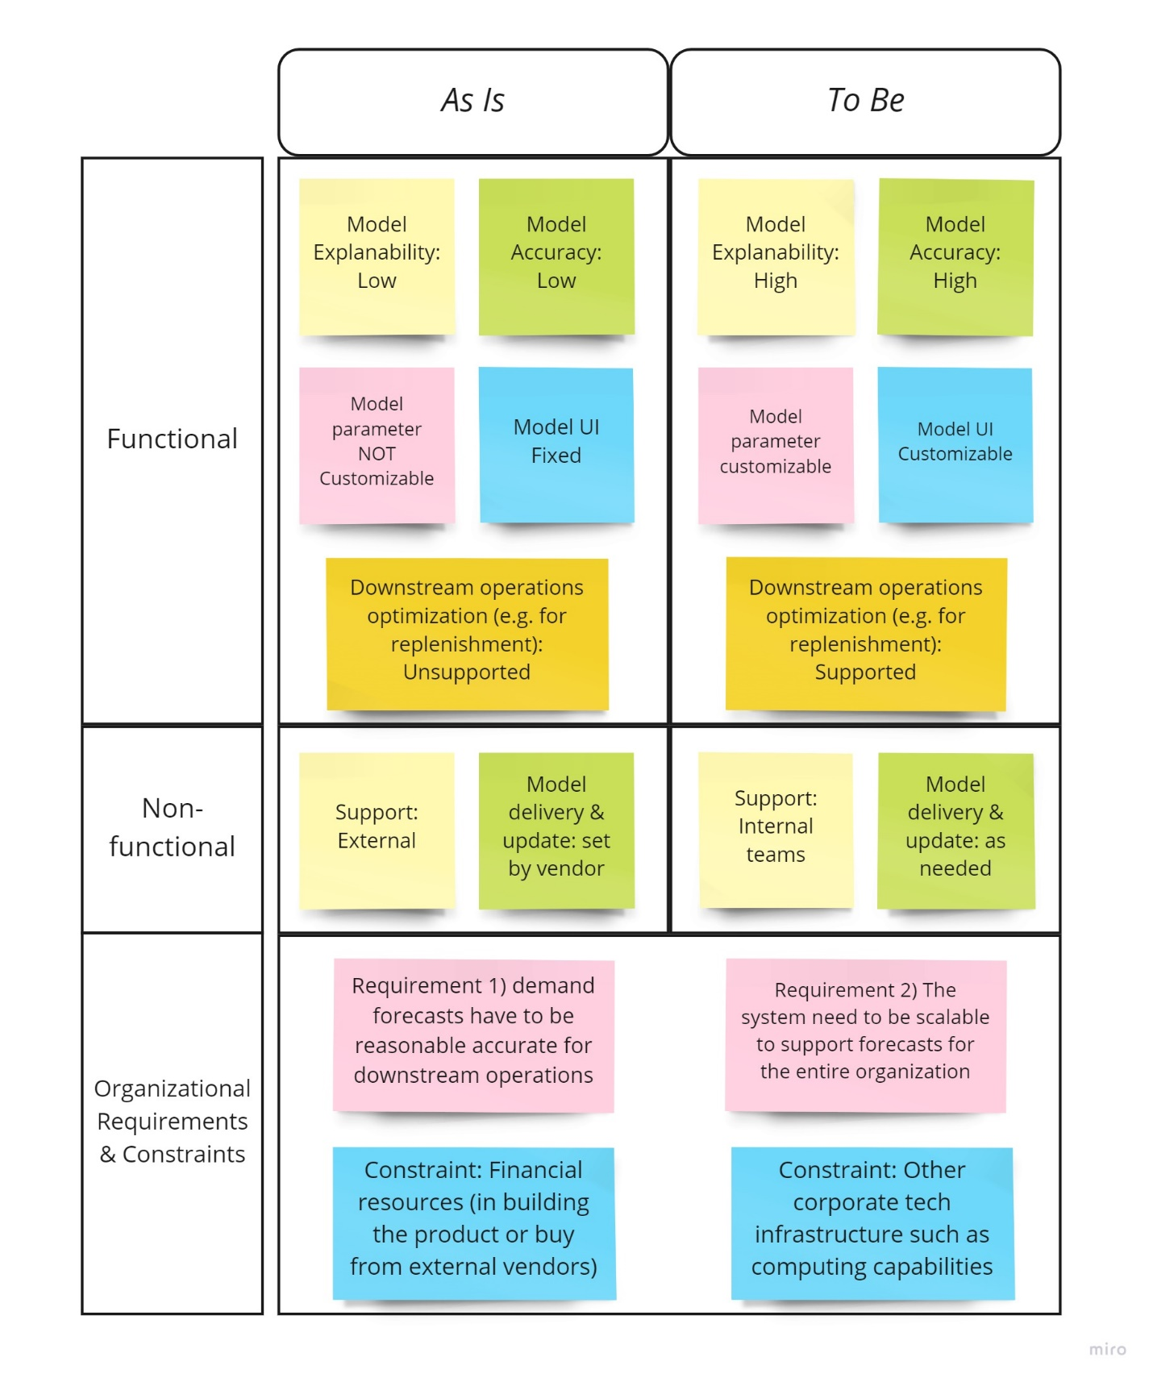

[Mayada Abdelrahman](https://canvas.stanford.edu/courses/122184/users/285085)

## [Mayada Abdelrahman](https://canvas.stanford.edu/courses/122184/users/285085)

Oct 26, 2020Oct 26 at 4:05am

[Manage Discussion Entry](https://canvas.stanford.edu/courses/122184/discussion_topics/537481)

**Automating capturing meeting highlights using AI:**

### **Goals:**

* 1. Provide meeting attendees with an automated way of capturing meeting highlights and action items to save time invested from meeting attendees to capture, consolidate and share meeting notes while deviating them from focusing on meeting conversation
  2. Instead of having multiple meeting attendees capture meeting notes and spending time to verify, compare notes, consolidate and share them, this tool should target decreasing the time taken by meeting attendees to capture meeting notes/highlights by at least 50%

### **KPIs:**

* 1. Time saved by the automation of the process for capturing meeting notes
  2. Accuracy of the tool that predicts/recommends the meeting notes



### **On #6 in the HW#3:**

* 1. **I spoke to data scientists on my team and their recommendation is to collect a golden data set where meeting attendees would manually take meeting notes of their meeting and this data will be used to train a model that can predict meeting highlights.**
  2. **The data set should include:**
     + **At least 50 real business meetings**
     + **2 or more participants per meeting**
     + **Preferably more than one person would create meeting motes for the same meeting**
  3. **Constraints/Challenges to data collection for this feature:**
     + **Meeting attendees need an incentive to participate in this experiment to provide the data needed**
     + **Large dataset needed requires onboarding a lot of users to collect and consolidate input**
     + **Data needs to be gathered from real business meetings so that we can have domain specific data that would lead to higher accuracy of the prediction/recommendations model**
     + **Data labeling vendors ex: Lionbridge have 2 constraints:**
       - **Price to acquire data is very expensive ex: $7/min for transcription services in english language; higher for foreign languages**
       - **Data from vendors are prompted or scripted which wouldn't create a national distribution of meeting demographics which might impact the accuracy of the model**

# **Industry:** IoT/Smart Home/Smart Glass Industry

* **Industry:** IoT/Smart Home/Smart Glass Industry

**Problem Statement**: How to remote commission a customer site with Smart Glass/Window (one kind of high-end glass that adjust its color or tint according to different weather conditions, geographical locations and user preferences etc) using AI, instead of manually making customizations & site visits which are very costly and not scalable.

**Background:** As a new emerging industry, commissioning a customer site with electrochromic Smart Glass (powered by electricity and connected to the Internet) can be very lengthy and costly. In addition to physically install the Glass, all other supporting systems such as sensors, power supply as well as the software which controls the Glass Tint (color) have to be commissioned properly. Right now the commissioning process heavily involved different functional team visiting a customer site to commission different part of the system, such as a LVE (Low Voltage Electrician) for the power, FSE (Field Service Engineer) for the sensors and CSMs (Customer Success Managers) for a 3D model etc.

**Why AI can be a Solution**: As Smart Glass is being adopted by more users and data is being accumulated, AI can be introduced to streamline a lot of originally manual and repeated process such as setting sensor parameters, adjusting 3D models for Smart Glass to function well. Manpower can be reduced in this process or even obliterated. With better understanding of the Smart Glass, the customer can be shifted from a "stander-by" position to a more involved user position or even designer position.

**User Journey Map**:

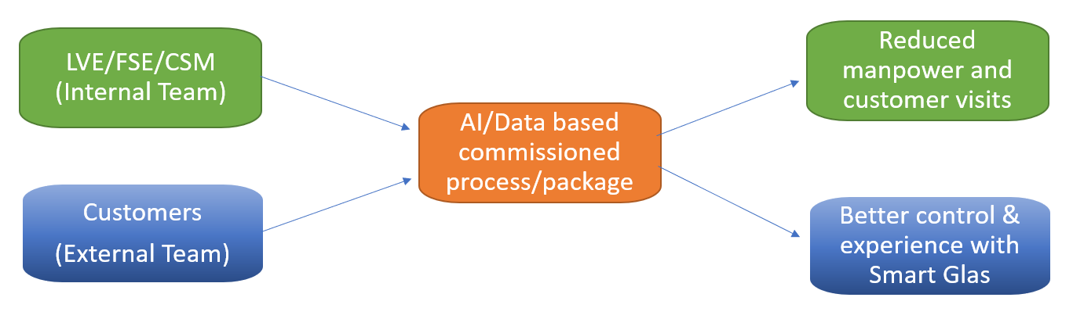

**Buyer Utility Map:**

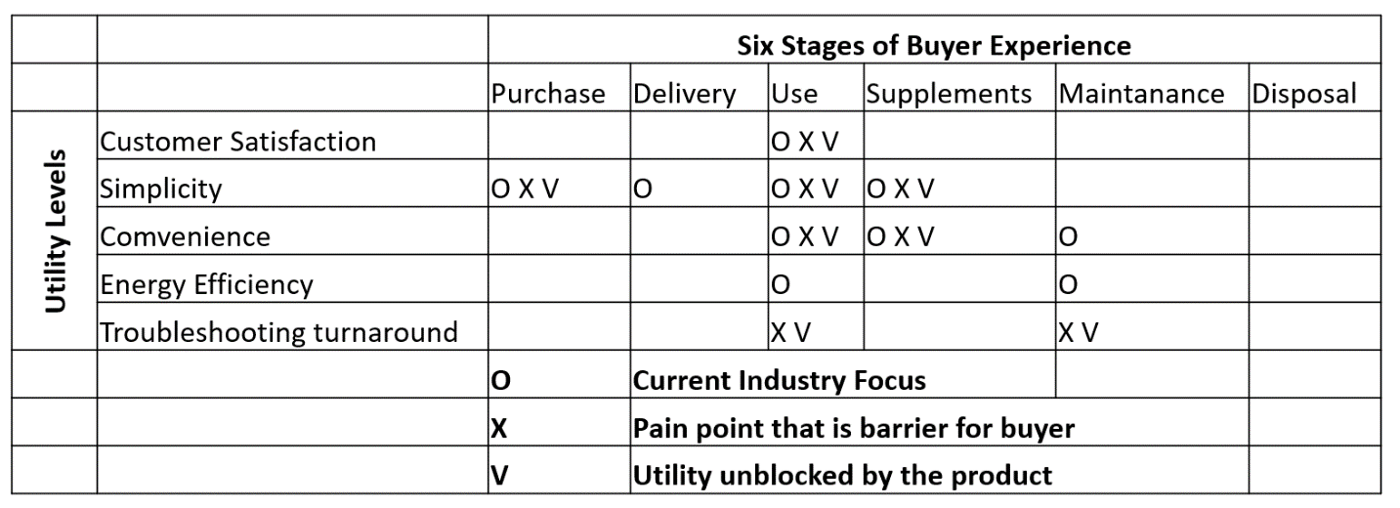

**4 Actions Framework**:

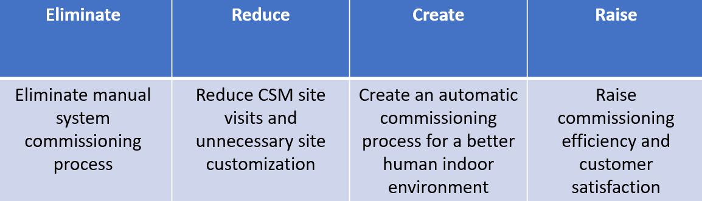

Edited by [Yuyang Ying](https://canvas.stanford.edu/courses/122184/users/251802) on Oct 20 at 6:43pm

[Adnan Boz](https://canvas.stanford.edu/courses/122184/users/240769)

## [Adnan Boz](https://canvas.stanford.edu/courses/122184/users/240769)

Oct 18, 2020Oct 18 at 8:15pm

[Manage Discussion Entry](https://canvas.stanford.edu/courses/122184/discussion_topics/531181)

Hi Joseph,

Would you please follow the homework 1 and homework 2 guide?

Thanks,

Adnan

**Industry: AI Consulting Platform**

**Problem:** Enterprise companies (<$500M Market Cap/Valuation) lack access to AI expertise.  How to tap into this market to provide vetted AI expertise to those in need (providing a platform and product service offerings)?

**Background:** Enterprises (<$500M Market Cap/Valuation) will need to leverage AI expertise to remain competitive.

**Relevance:** The likes of BCG GAMMA, Deloitte Omnia AI, & McKinsey Quantum Black are expensive and out of reach for smaller enterprises. Lack of access to in-house AI talent will confront these firms as the focus on speed, cost, deployment and scalability is the norm.

**Objective:** The purpose of this research is to examine how to reach our target customer, decide on the platform and how to productize the service offering.

**Source:** DAIMLAS business model concept



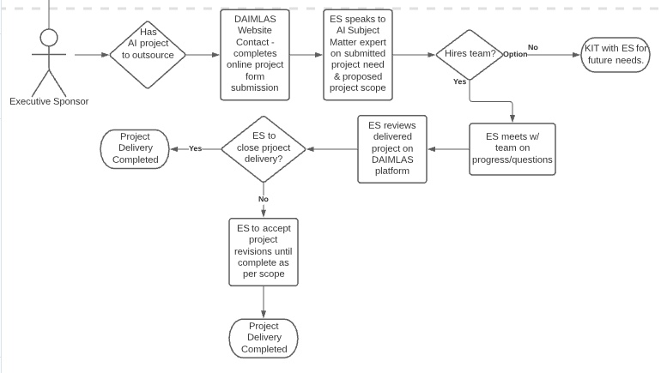

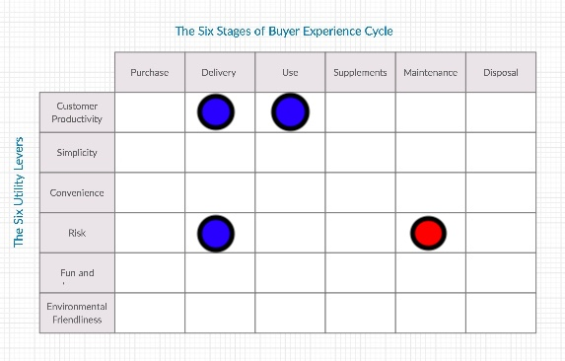

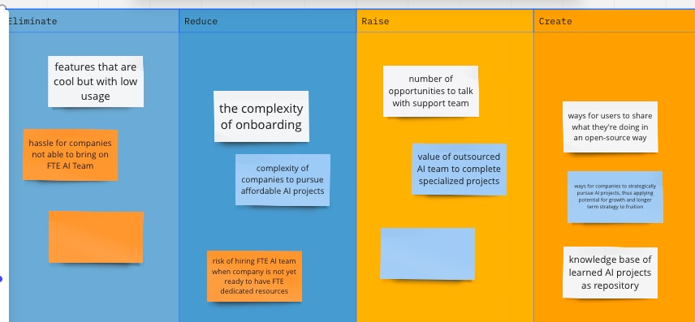

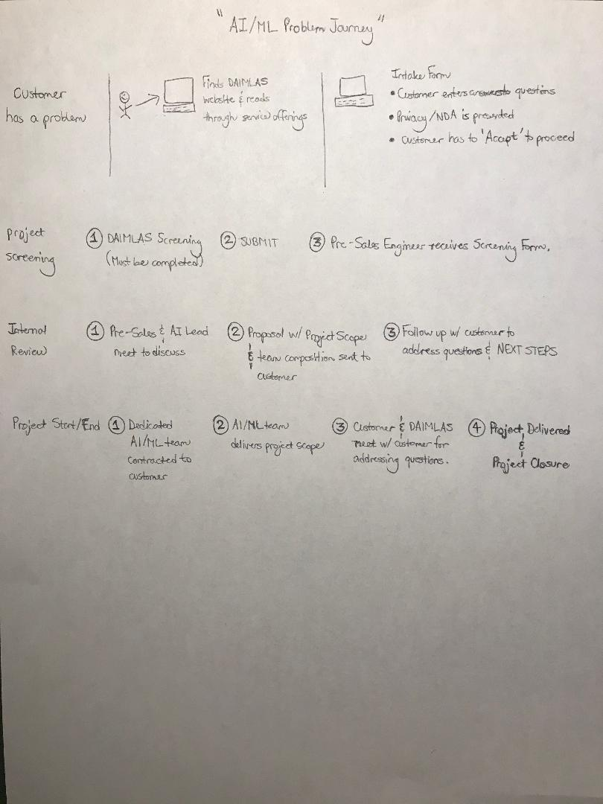

# Online Media

**Background**

**Domain:**News

**Sub-domain:**News Feed

**Problem Description:**

***Ideal***: A user has an easy means to discover news & updates around the world on the latest happenings, Business, Technology, AI, Health Sciences, Education and other topics based on user’s interest.

***Reality***: A user finds it difficult to find a single hub for getting all the relevant, authentic & in-context updates & news. A user has to visit various apps, channels to consume different topics of news & does not know whether or not to trust all the news/feed updates.

***Consequences***: A user ends up switching between multiple channels and media apps to gather news on their topics of interest. It can also result into consuming fake news or out-of-context news leaving the user frustrated and more anxious, especially in the current unprecedented times of lockdown and little social interaction.

***Proposal****:*To solve the pain points of users a single news hub where trustworthy news is aggregated and presented in easy consumable form to the user based on their areas of interest & allowing discovery of new topics.

***Map: Understand Long Term Goals:***

* To understand the user’s topics of interest for news & daily/weekly updates.
* To aggregate the news on the topics of interest from trustworthy sources.
* To present the daily/weekly updates on the topic of interest to the user.
* To recommend topics for discovery & learning to the user about the other latest news around the world that might become topic of interest for the user in future.

***User Persona:***

* Demographics
  + Name: Shelly Welton
  + Female, Age 34
  + Education: Master in Electronics Engineering & MBA
  + Profession: Management in Tech & Software
  + Archetype: Explorer
* Bio
  + Sheryl is a tech geek. She loves reading and giving her opinion on the new products, happenings around the world.
  + She lives in New York
  + She has a lot of friends and she enjoys volunteering for Social Causes impacting her immediate community in the neighborhood.
  + She is love Nat Geo, Discovery Channel and watching documentaries. She also loves to stay up to date on the latest gadget arrivals in the market and likes to review the products and post her social profile.
  + She currently uses many apps to get various updates on latest happenings, Business, Technology, Electronics and AI.
* Goals
  + Easy discovery of updates
  + Trustworthy News & updates on latest happenings, Business, Technology, Electronics and AI.
  + Easily digest the updates and share on social profile & comment on topics.
* Personality
  + Social
  + Freedom
  + Extrovert
  + Thinking & Feeling balanced
  + Judging & Perceiving balance
* Pain points
  + Keeps switching between multiple channels and media apps to gather news on her topics of interest.
  + Difficult to decide if news is trustworthy.
  + Frustrated when served with out-of-context news

***User Journey:***

* + Easy discovery of updates
  + Trustworthy News & updates on latest happenings, Business, Technology, Electronics and AI.
  + Easily digest the updates and share on social profile & comment on topics.

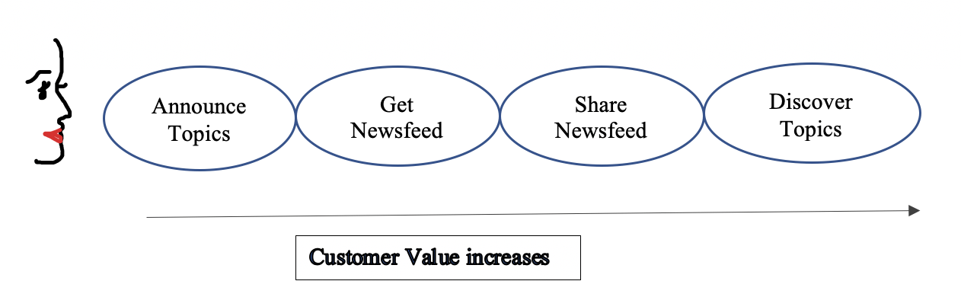



**TRAVEL**

Industry: Travel

[https://docs.google.com/document/d/1OsUXIEe_7k--SP0jhDepJKtJP6LGQWe5WyDYuAszQCo/edit?usp=sharing (Links to an external site.)](https://docs.google.com/document/d/1OsUXIEe_7k--SP0jhDepJKtJP6LGQWe5WyDYuAszQCo/edit?usp=sharing)

I am having a hard time cutting and pasting it here - do you have any suggestions of how to translate it?

Problem Statement: Customers need to wait in line at airports for checkin and security, causing annoyance, stress and in this time of pandemic, increasing risk of infection.

Value for customer: air travel is a very stressful experience and any improvement will be very well received.

AI opportunity: Facial scan to identify user, luggage scan to identity security risks.

Remaining details are in the doc.

[https://docs.google.com/document/d/1OsUXIEe_7k--SP0jhDepJKtJP6LGQWe5WyDYuAszQCo/edit?usp=sharing (Links to an external site.)](https://docs.google.com/document/d/1OsUXIEe_7k--SP0jhDepJKtJP6LGQWe5WyDYuAszQCo/edit?usp=sharing)

# Logistics | Retail | Demand Forecasting

Industry: Logistics | Retail | Demand Forecasting

Demand forecasting is a common problem in supply chain and logistics. One such example is in the **retail** space - forecasting demand for items sold in the store.

With a robust and accurate demand forecasting engine, operations and logistical decisions in the supply chain can be made with confidence. Managers would know how to **replenish inventory** (how often, what’s the quantity), can **optimize for logistics** (from which distribution center to transport), how to do item pricing and clearance decisions (e.g. if an item is not selling as well as predicted, the company can consider a promotion to get rid of it sooner).

A good demand forecasting engine provides good inputs to make all these important operations decisions.

Traditional solution & Opportunity Space: Even big retailers have large teams of inventory analysts to manually input numbers according to their knowledge of items. Many of the processes can be automated and done better with AI.

There are off-the-shelf demand forecasting analytics solutions provided by traditional software provider (e.g. IBM, Oracle) that cost over $10mm/year and does not perform up to the standard of modern applications. The opportunity to make new demand forecasting engines and make a significant financial impact is huge. For one thing, it could save on the subscription cost of traditional models (in the millions). For another, a good demand forecasting engine could inform sound logistical and operations decisions, which directly affects the bottom line of the company.

Why AI solution is a good idea: 1) requirements of big data; 2) large computation and processing capabilities (think tens of thousands of items sold in the stores) and 3)  utilize model training and algorithms - predictions can be more accurate than human inputs and be improved over time.

Potential users: All the businesses with a complex catalog of products - for example, retailers, airline companies, hospitality industry, restaurants. A good demand forecasting engine can inform supply chain and inventory decisions, demand anticipation and capture, pricing decisions, and more.

**Week 1 Homework**

User Journey Map:

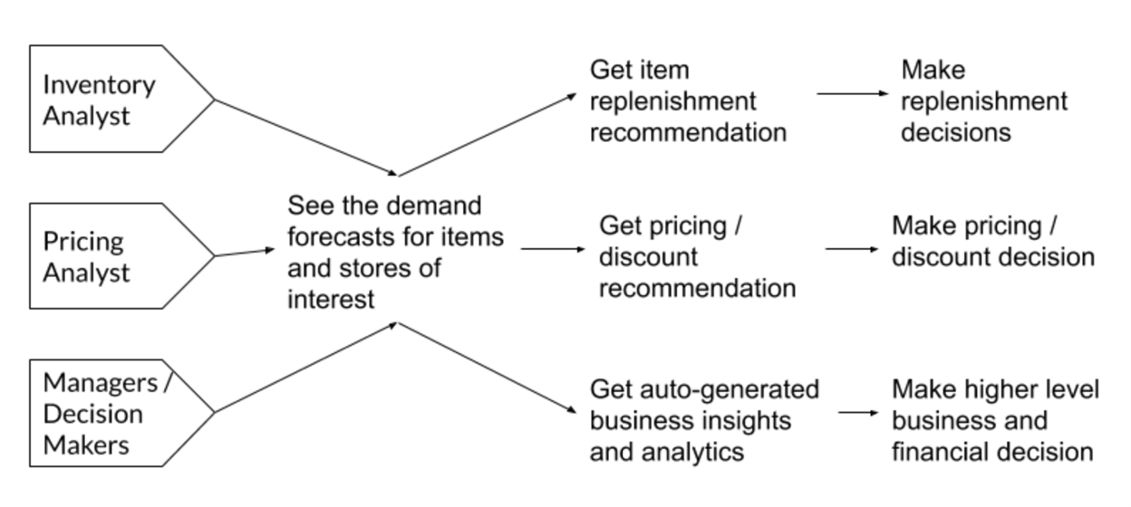

**Week 2 Homework**

(1) Buyer Utility Map

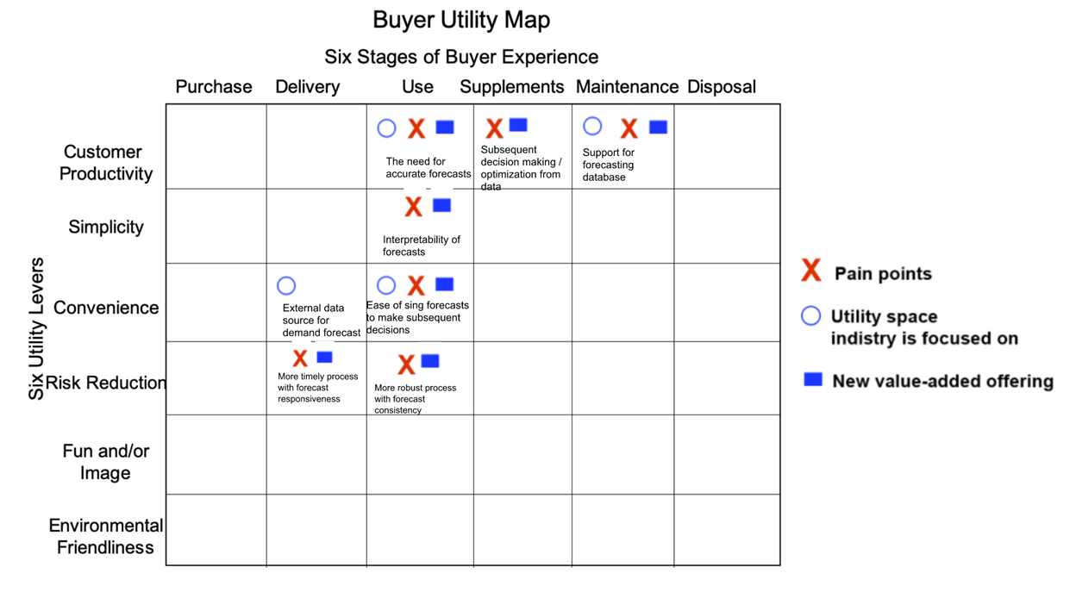

(2) Four Actions

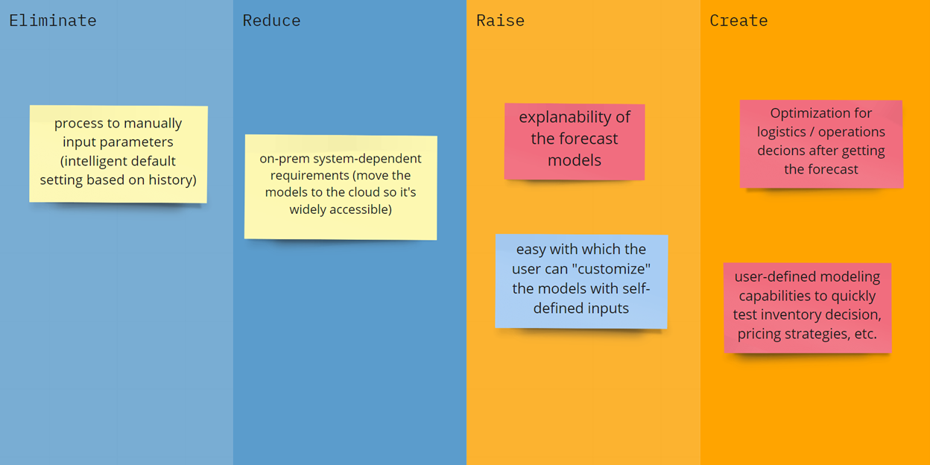

Edited by [Jiawen Xu](https://canvas.stanford.edu/courses/122184/users/285447) on Oct 18 at 10:18pm

"Why is it more important to start with framing the problem and running customer validation in AI projects compared to non-Ai projects?"

My answer is for your question is,

While dealing with AI projects, first thing to focus as a product manager is the goal setting and framing the problem and decide what to achieve?

If we implement the AI project, we need to think, what the cost savings are to the customer? We will have to run customer validation to find out benefits from AI project like swifter speed to market, increased annual enterprise revenue, Increased product, service, experience presentment and to validate enhanced customer experience.